**BLOCKCHAIN BASED SECURE DATA TRANSFER**

**IN CLOUD STORAGE**

## A PROJECT REPORT

***Submitted by***

**ABITHA.U [REGISTER NO: 211419104004]**

**KAVIASREE.S [REGISTER NO: 211419104129]**

**PHOOJA SHREE.R [REGISTER NO: 211419104189]**

***in partial fulfillment for the award of the degree***

***of***

**BACHELOR OF ENGINEERING**

**IN**

## COMPUTER SCIENCE AND ENGINEERING

## 

**PANIMALAR ENGINEERING COLLEGE**

**(An Autonomous Institution, Affiliated to Anna University, Chennai)**

## APRIL 2023

**PANIMALAR ENGINEERING COLLEGE**

**(An Autonomous Institution, Affiliated to Anna University, Chennai)**

**BONAFIDE CERTIFICATE**

Certified that this project report **“BLOCKCHAIN BASED SECURE DATA TRANSFER IN CLOUD STORAGE”** is the bonafide work of “**ABITHA.U (211419104004), KAVIASREE.S (211419104129) and PHOOJA SHREE.R (211419104189)”** who carried out the project work under my supervision.

**SIGNATURE SIGNATURE**

**Dr. L. JABASHEELA, M.E., Ph.D., Dr. K. SANGEETHA, M.E., Ph.D.,**

**HEAD OF THE DEPARTMENT SUPERVISOR**

**ASSOCIATE PROFESSOR**

DEPARTMENT OF CSE, DEPARTMENT OF CSE,

PANIMALAR ENGINEERING COLLEGE, PANIMALAR ENGINEERING COLLEGE,

NASARATHPETTAI, NASARATHPETTAI,

POONAMALLEE, POONAMALLEE,

CHENNAI-600 123. CHENNAI-600 123.

Certified that the above candidate(s) was/ were examined in the End Semester Project Viva-Voce Examination held on...........................

## INTERNAL EXAMINER EXTERNAL EXAMINER

**DECLARATION BY THE STUDENT**

We **ABITHA. U (211419104004), KAVIASREE. S (211419104129) and PHOOJA SHREE. R (211419104189)** hereby declare that this project report titled **“BLOCKCHAIN BASED SECURE DATA TRANSFER IN CLOUD STORAGE”**, under the guidance of **Dr. K. SANGEETHA, M.E., Ph.D.,** is the original work done by us and we have not plagiarized or submitted to any other degree in any university by us.

**ABITHA. U**

**KAVIASREE. S**

**PHOOJA SHREE. R**

**ACKNOWLEDGEMENT**

We would like to express our deep gratitude to our respected Secretary and Correspondent **Dr.P.CHINNADURAI, M.A., Ph.D.,** for his kind words and enthusiastic motivation, which inspired us a lot in completing this project.

We express our sincere thanks to our Directors **Tmt.C.VIJAYARAJESWARI**, **Dr.C.SAKTHI KUMAR, M.E., Ph.D.,** and **Dr.SARANYASREE SAKTHI**

**KUMAR B.E., M.B.A., Ph.D.,** for providing us with the necessary facilities to undertake this project.

We also express our gratitude to our Principal **Dr.K.Mani, M.E., Ph.D.,** who facilitated us in completing the project.

We thank the Head of the CSE Department, **Dr.L. JABASHEELA, M.E., Ph.D.,** for the support extended throughout the project.

We would like to thank our project guide **Dr. K. SANGEETHA, M.E., Ph.D.,** and all the faculty members of the Department of CSE for their advice and encouragement for the successful completion of the project.

## ABITHA.U (211419104004), KAVIASREE.S (211419104129),

## PHOOJA SHREE.R (211419104189)

**ABSTRACT**

The growth in technological advancements has led to the abrupt rise in the improvement of digital belongings and transactions. The documents or files are more prone to information breaches and theft from the intruders who are successful in obtaining the data. In this work, we describe a security system that protects sensitive data. A important piece of data is stored in the cloud. Compared to traditional physical storage, cloud storage offers a number of advantages, including more readily available data storage. You may exchange files and collaborate with others effortlessly using the cloud. A blockchain is a type of digital database that can hold a tonne of data. One of the secure information technologies that is developing quickly and aids in giving data security is blockchain. Data is protected from hacking via blockchain technology. Data that has been initialized by the user cannot be edited or exchanged, which gives user data an ever-increasing level of protection. Data privacy is unharmed because the user data cannot be shared with unauthorized users in the network except the current and authorized user. Along with the blockchain approaches, AES encryption and decryption algorithm is implemented in this project. The process of encryption turns the original data into an unrecognizably altered state. The private data will be secure as a result. The hash code algorithm is also used such as SHA-256. SHA-256 is secure and has not been "broken," which is the main reason why technology employs it. So the data stored in the cloud is more secured and the data security against malicious activity is carried out by examining the authorized users IP address and email.

**TABLE OF CONTENTS**

|  |  |  |
| --- | --- | --- |
| **CHAPTER NO.**  **1.**  **2.**  **3.**  **4.**  **5.**  **CHAPTER NO.**  **6.**  **7.**  **8.** | **TITLE**  **ABSTRACT**  **LIST OF TABLES**  **LIST OF FIGURES**  **LIST OF SYMBOLS, ABBREVIATIONS**  **INTRODUCTION**   * 1. Problem Definition   **LITERATURE SURVEY**  **SYSTEM ANALYSIS**  3.1 Existing System  3.2 Proposed System  3.3 Feasibility Study  3.4 Hardware Environment  3.5 Software Environment  **SYSTEM DESIGN**  4.1 ER diagram  4.2 Data Flow Diagram  4.3 UML Diagrams  **SYSTEM ARCHITECTURE**  5.1 Architecture Overview  5.2 Module Design Specification  **TITLE**  **SYSTEM IMPLEMENTATION**  6.1 Algorithms  **PERFORMANCE ANALYSIS**  7.1 Web Testing  7.2 Test Cases & Reports  **CONCLUSION**  8.1 Conclusion  8.2 Future Enhancements  **APPENDICES**  Appendix 1 Coding  1.1 Client-side coding  1.2 Server-side coding  Appendix 2 Sample Screenshots  **REFERENCES** | **PAGE NO.**  iii  vi  vii  ix  1  2  4  10  11  12  12  13  14  15  16  17  18  22  23  24  **PAGE NO.**  26  27  38  39  41  43  44  44  45  46  46  73  79  87 |

**LIST OF TABLES**

|  |  |  |
| --- | --- | --- |
| **TABLE NO.**  Table 3.1  Table 3.2  Table 5.1 | **TABLE NAME**  Hardware Requirements  Software Requirements  Modules | **PAGE NO.**  14  14  24 |

**LIST OF FIGURES**

|  |  |  |  |
| --- | --- | --- | --- |
| **FIGURE NO.**  Fig 3.1  Fig 4.1  Fig 4.2  Fig 4.3  Fig 4.4  Fig 4.5  Fig 4.6  Fig 4.7  Fig 5.1  Fig 6.1  Fig 6.2  Fig 6.3  Fig 6.4  Fig 6.5  Fig 6.6  Fig 6.7  Fig 6.8  Fig 6.9  Fig 6.10  Fig 6.11  Fig 6.12  Fig 6.13  Fig 6.14  Fig 6.15  Fig 6.16  Fig 6.17  Fig 6.18  Scr 2.1  Scr 2.2  Scr 2.3  Scr 2.4  Scr 2.5  Scr 2.6  Scr 2.7  Scr 2.8  Scr 2.9  Scr 2.10  Scr 2.11  Scr 2.12  Scr 2.13  Scr 2.14  Scr 2.15  Scr 2.16 | **FIGURE NAME**  An Example of File Storage  ER Diagram  DFD Level 0  DFD Level 1  DFD Level 2  Use Case Diagram  Sequence Diagram  Activity Diagram  System Architecture  Encryption Process  Example  Round Key  Adding Round Key  S-Box  Sub Bytes  Shift Rows  Mix Columns  Add Round Key  Final Output  AES Architecture  Hashing  Characteristics of SHA-256  Example of Hashing  Padding Bits  Padding Length  Initial Buffer  Compression Function  Homepage  Staff Register Page  Staff Login Page  Staff Homepage  Request Page  Download Page  Staff Add File Page  Manager Description Page  Manager Login Page  Manager Homepage  Manager Add File Page  Staff Description Page  View Page  Head Login Page  Head Homepage  Response Page | **PAGE NO.**  11  16  17  17  18  19  20  21  23  28  28  29  29  30  30  31  31  32  32  33  34  34  35  36  36  36  37  79  79  80  80  81  81  82  82  83  83  84  84  85  85  86  86 |  |

**LIST OF ABBREVATIONS**

|  |  |  |
| --- | --- | --- |
| **SHORTCUT**  AES  SHA  LAST  HDFS  IPFS  GDPR  P2P  LFSP | **ABBREVATION**  Advanced Encryption Standard  Secure Hash Algorithm  Location-Aware Storage Technique  Hadoop Distributed File System  Interplanetary File System  General Data Protection Regulation  Peer-to-Peer  Localized Fuzzy Search Protocol | **PAGE NO.**  2  3  5  5  5  8  9  9 |

**CHAPTER 1**

**INTRODUCTION**

**CHAPTER 1**

**INTRODUCTION**

## 1.1. PROBLEM DEFINITION

In our work, we examine how the data source is managed throughout the organization. The main objective of this project is to ensure the safety measures against the security breach. Technology developments have generated enormous amounts of data, including sensitive and personal information. Storage of data in the cloud is the recent arising technology of IT industry to solve the problems and difficulties of business database services such as storage capacity, performance, stability, security, load and many other issues. Cloud storage was used to provide the cloud-based data storage platform. Infrastructural and data management costs are decreased as a result. Vast services are offered by cloud providers. One of the most popular technologies today is blockchain. By utilizing block chain in the cloud and encryption decryption technology, we hope to create a system that will solve the issue of data security. These days, there are many security issues, including difficulties with access control, scalability, virtualization, privacy, and massive data processing. Traditional security methods are no longer suitable for data storage in recent times. Data exchange and storage on centralised servers typically encounter problems with data manipulation and authentication. By excluding malicious users, blockchain provides a platform for data and cloud storage, enhancing security. Blockchain is having a good effect and making it easier, faster, and more reliable to use storage, transactions, and business operations. Usage of blockchain in cloud storage has a benefit of increase in security of decentralized and centralizated system, which improves authorization, privacy, and efficiency. Taking into account the case of a company or an organization, the confidential files are first converted to fixed-sized blocks of data which are provided primary encryption using AES. Then we divide the file into fixed blocks and hash it, further converted to bytes and stored

in a blockchain. The benefits of Advanced Encryption Standard (AES) algorithm, it uses higher length key sizes such as 128, 192 and 256 bits for encryption. For the security concerns Secure Hash Algorithm 256-bit (SHA-256) is employed which obtain the leading position for the most secured algorithm and it's used for cryptographic security. This algorithm converts the file key and QR Code key (generated when downloading the file) into hash value which makes the storage of the data more secure. The user can access the file only if the secret key entered matches the hash value stored in database or cloud storage. If the hacker attempts to access the file by requesting it to the head they get a denied message because their device IP Address is not stored in the organizations database or cloud storage. By doing so the data that are stored in the cloud storage of the organization are more secure against the hackers.

# CHAPTER 2

# LITERATURE SURVEY

**CHAPTER 2**

**LITERATURE SURVEY**

**2.1. Detecting Suspicious File Migration or Replication in the Cloud**

**Author:** Adam Bowers, Cong Liao, Douglas Steiert, Dan Lin, Anna Squicciarini, and Ali Hurson

**Year:** 2021

**[1]** The technique used is LAST-HDFS which integrates Location-Aware Storage Technique (LAST) into the open source Hadoop Distributed File System (HDFS). The LAST-HDFS system enforces location-aware file allocations and continuously monitors file transfers to detect potentially illegal transfers in the cloud. Illegal transfers here refer to attempts to move sensitive data outside the (“legal”) boundaries specified by the file owner and its policies.

**Merits:** It is capable of detecting potential illegal transfers which moves sensitive

data outside the boundaries specified by the file owner.

**Demerits:** It may lead to malicious activities in various ways, such data will be known by unknown users, data or file maybe lost.

**2.2. Decentralized File Transfer System Blockchain-based File Transfer**

**Author:** Anusree K, Jagan Sathiaseelan Vadekkat, Abhinu R Dev, Abhinav

**Year:** 2022

**[2]** The purpose is to solve the need for blockchain applications to exchange larger files with sensitive information within an organization using Inter Planetary File System (IPFS). IPFS aims to create a file system that connects all computer devices. Even though IPFS proposes putting the immutable, permanent IPFS links into a blockchain transaction, it is believed that several elements of IPFS can be improved by combining it with blockchain.

**Merits:** The goal of this system is to use the blockchain concept to promote file sharing services with greater security and lower risk.

**Demerits:** Anyone connected to the database can check other user’s rights for the file they are sharing.

**2.3. An Android File Sharing System Using BlockChain & IPFS**

**Author:** Devesh Solanki, Dev Mehta, Kaushal Modani, Sashank R M Dr Rashmi S

**Year:** 2021

**[3]** The Android App is designed for secure storage and protection using BlockChain and IPFS. Mobile devices include extensive data storage including sensitive objects such as verification credentials, photos, videos, personal information, activity details, and much more. Therefore, protecting data stored on mobile devices becomes a serious problem. In this work, they are investigating the safety of the Android storage.

**Merits:** As blockchain is immutable, it is not possible to alter the package information in any way.

**Demerits:** Different types of attacks on the sensitive data is possible.

**2.4. Blockchain - Based Secure Storage and Access Scheme For Electronic Medical Records in IPFS**

**Author:** Jin Sun, Xiaomin Yao, Shangping Wang, and Ying Wu

**Year:** 2020

**[3]** Electronic medical records can help people prevent diseases, improve cure rates, provide a significant basis for medical institutions and pharmaceutical companies, and provide legal evidence for medical negligence and medical disputes. However, the integrity and security problems of electronic medical data still intractable. In this paper, based on the cipher text policy attribute-based encryption system and IPFS storage environment, combined with blockchain technology, constructed an attribute-based encryption scheme for secure storage and efficient sharing of electronic medical records in IPFS storage environment.

**Merits:** The scheme provides good access control for the electronic medical records using attribute-based encryption technology so that people who are not related to the patient cannot see the private data of the patient without authorized.

**Demerits:** Access privilege is one of the shortcoming.

**2.5. File Storing and Sharing using Blockchain**

**Author:** Anjaly Renny, Anjana Santhosh, Neeraja S, Teena Noyal

**Year:** 2020

**[5]** This paper deals with secure file sharing in an organization or enterprise by the application of certain modified encryption methods and a unique way of storing the file by adopting concepts used in blockchain technology. Normally the files are stored and shared in a centralized way. By using a centralized way of storing and sharing files, it becomes highly vulnerable to data breaches. So, in order to overcome this, they are introducing more efficient encryption standards. It focuses on modified AES encryption in the first stage and a technique called visual cryptography as part of re-encryption.The File Storing and Sharing is done using Blockchain and AES algorithm.

**Merits:** It is much secure, efficient and effective.

**Demerits:** Suspicious activities may occur.

**2.6. Towards Blockchain - based Scalable and Trustworthy File Sharing**

**Author:** Shujie Cui, Muhammad Rizwan Asghar, Giovanni Russello

**Year:** 2018

**[6]** In blockchain-based systems, malicious behavior can be detected using auditable information in transactions managed by distributed ledgers. In this work, they propose a blockchain and proxy re-encryption based design for encrypted file sharing that brings a distributed access control and data management. By combining blockchain with proxy re-encryption, the approach not only ensures confidentiality and integrity of files, but also provides a scalable key management mechanism for file sharing among multiple users.

**Merits:** It provides a scalable key management mechanism for multiple access.

**Demerits:** Any user with valid login details can access the data.

**2.7. Blockchain-based Personal Health Data Sharing System Using Cloud Storage**

**Author:** Xiaochen Zheng, Raghava Rao Mukkamala, Ravi Vatrapu, Joaqun Ordieres-Mere

**Year:** 2018

**[7]** With the advent of rapid development of wearable technology and mobile computing, huge amount of personal health-related data is being generated and accumulated on continuous basis at every moment. Currently most of such datasets are stored and controlled by different service providers and this centralised data storage brings challenges of data security and hinders the data sharing. The primary goal of this work is to enable users to own, control and share their personal health data securely, in a General Data Protection Regulation (GDPR).

**Merits:** It uses different solutions to share the large size continuous-

dynamic data using hash pointers to the storage location.

**Demerits:** Data leakage is possible.

**2.8. Blockchain - Based, Decentralized Access Control for IPFS**

**Author:** Mathis Steichen, Beltran Fiz, Robert Norvill, Wazen Shbair and Radu

**Year:** 2018

**[8]** Large files cannot be efficiently stored on blockchain. IPFS is a file sharing system that can be leveraged to more efficiently store and share large files. It relies on cryptographic hashes that can easily be stored on a blockchain. Nonetheless, IPFS does not permit users to share files with selected parties. This is necessary, if sensitive or personal data needs to be shared. Therefore, this paper presents a modified version of the InterPlanetary Filesystem (IPFS) that leverages Ethereum smart contracts to provide access controlled file sharing. The smart contract is used to maintain the access control list, while the modified IPFS software enforces it.

**Merits:** Users can efficiently share large files and still benefit from the blockchain.

**Demerits:** The file requested by different user is accessed by the specific user based on the priority of the request.

**2.9. Blockchain-based System for Secure Data Storage with Private Keyword Search**

**Author:** Hoang Giang Do, Wee Keong Ng

**Year:** 2017

**[9]** Traditional cloud storage has relied almost exclusively on large storage providers, who act as trusted third parties to transfer and store data. This model poses a number of issues including data availability, high operational cost, and data security. In this paper, introduced a system that leverages blockchain technology – RSA Algorithm to provide a secure distributed data storage with keyword search service. The system allows the client to upload their data in encrypted form, distributes the data content to cloud nodes and ensures data availability using cryptographic techniques.

**Merits:** This system allows the client to upload their data in encrypted form, distributes the data content to cloud nodes and ensures data availability using cryptographic techniques.

**Demerits:** The encrypted dataset which is having a complex private keyword is difficult to search.

**2.10. Detecting illegal file sharing in Peer-to-Peer networks using fuzzy queries**

**Author:** Marlene Goncalves, Graciela Perera and Stephen Rodabaugh

**Year:** 2010

**[10]** The advent of Unstructured Peer-to-Peer (P2P) networks enables large amounts of content to be distributed over Internet. However, billions of dollars are lost every year as a consequence of illegal file sharing or piracy. This paper has presented an architecture that enriches the process of detecting illegal sharing files in P2P networks using fuzzy queries. Fuzzy queries are useful to express user’s criteria that allow identifying and discriminating suspicious hosts, answers are discriminated by the membership function. This architecture integrates fuzzy queries and an inference process with a P2P protocol called Localized Fuzzy Search Protocol (LFSP). The LFSP decreases P2P traffic and enables the discovering possible sources of illegal file sharing by querying directly the P2P sources.

**Merits:** To detect possible sources of illegal file sharing.

**Demerits:** If the fuzzy queries are complex then it is difficult to rewrite using reformulator.

# CHAPTER 3

# SYSTEM ANALYSIS

## CHAPTER 3

## SYSTEM ANALYSIS

## EXISTING SYSTEM

## Cloud storage has experienced a rapid increase in popularity in recent years. While though cloud storage has numerous benefits, such as simplicity and flexibility, users frequently have no idea where their data is actually stored. This restriction can make consumers less confident and less inclined to trust the storage provider, or it might even make the cloud unsuitable for storing data with stringent geographical requirements. In the existing a solution named LAST-HDFS to solve this problem by integrating Location-Aware Storage Technique (LAST) into the free and open-source Hadoop Distributed File System (HDFS). To identify possibly illegal transfers in the cloud, the LAST-HDFS system enforces location-aware file allocations and continuously tracks file transfers. Here, "illegal transfers" refers to endeavours to transfer confidential information outside the ("legal") restrictions imposed by the file owner and its regulations. The algorithms used maximize the chance of storing data items with comparable privacy preferences in the same region and describe file transfers among nodes as a weighted graph. Provided with a socket monitor that can track the real-time communication taking place among cloud nodes on each individual node.

## 

Fig 3.1. An Example of File Storage

## Disadvantages of Existing System:

* There is a chance to make the login process by unknown users with valid user’s mail ids.
* It may lead to make the malicious activities in various ways such data will be knows by unknown users.

## PROPOSED SYSTEM

The Proposed System considers an organization into account where the input file or data which a project manager or any other employee in a particular organization needs to share with others in the organization is converted into fixed-sized blocks of data, which is apparently similar to the concept used in blockchain. Here the manager browses and adds different files for each section of employees with different access rights, so the employee with the respective access right (valid organization IP address) could request for the file and with the valid secret key the employee can access the entire file. The approach not only ensures confidentiality and integrity of files, but also provides a scalable key management mechanism for file sharing among multiple users. In the proposed work when an unknown user make the request, they could not access the data, it will show empty or null value in authorized panel services. After checking the requests by authority person, if the user is valid, then the user can get the response through mail and if the user is not valid then their request will be rejected. The Blockchain algorithm we use here is SHA-256 and AES for encryption and decryption of Data.

## Advantages of Proposed System:

## It gives standard and valid solution to process the data with the hash function.

## Data is encrypted using AES and stored in the cloud.

## Block chain is used to connect the hash values.

## QR Code generation.

## 3.3. FEASIBILITY STUDY

Feasibility studies aim to objectively and rationally uncover the strengths and weaknesses of the existing business or proposed venture, opportunities and threats as presented by the environment, the resources required to carry through, and ultimately the prospects for success. In its simplest term, the two criteria to judge feasibility are cost required and value to be attained. As such, a well-designed feasibility study should provide a historical background of the business or project, description of the product or service, accounting statements, details of the operations and management, marketing research and policies, financial data, legal requirements and tax obligations. Generally, feasibility studies precede technical development and project implementation.

They are 3 types of Feasibility:

* Economic feasibility
* Technical feasibility
* Operational feasibility

## Economic Feasibility:

Here, we track down the absolute expense and advantage of the proposed framework over current framework. For this venture, the primary expense is administration cost. This fills in as a straightforward web application which is cost productive. Additionally, it is basic in activity and doesn’t cost preparing or fixes.

## Technical Feasibility:

## It incorporates figuring out advancements for the undertaking, both equipment and programming. Here, the base equipment prerequisite is 2GB RAM and Core i5 Processor and the product necessities incorporate Windows OS, MySQL and Eclipse IDE. The backend innovation utilized is JAVA. Since, it is stage free and can be utilized in assortment of uses.

**3.3.3 Operational Feasibility:**

Operational feasibility is dependent on human resources available for the project and involves projecting whether the system will be used if it is developed and implemented. This project is operationally feasible for the users as nowadays almost everyone are familiar with websites and digital technology.

## 3.4. HARDWARE REQUIREMENTS

The hardware requirements may serve as the basis for a contract for the implementation of the system and should therefore be a complete and consistent specification of the whole system. They are used by software engineers as the starting point for the system design. It shows what the system does and not how it should be implemented.

|  |  |
| --- | --- |
| **System** | Core i5 Processor |
| **Hard Disk** | 250 GB |
| **Monitor** | 15’’ LED |
| **Input Devices** | Keyboard, Mouse |
| **Ram** | 2 GB |

Table 3.1. Hardware Requirements

## 3.5. SOFTWARE REQUIREMENTS

The software requirements is the specification of the system. It should include both a definition and a specification of requirements. It is a set of what the system should do rather than how it should do it. The software requirements provide a basis for creating the software requirements specification. It is useful in estimating cost, planning team activities, performing tasks and tracking the teams and tracking the team’s progress throughout the development activity.

|  |  |
| --- | --- |
| **Operating System** | Windows 10 |
| **Coding Language** | Java |
| **IDE** | Eclipse |
| **Front End** | HTML, CSS, JSP |
| **Back End** | My SQL 5.5, AWS Cloud |

Table 3.2. Software Requirements

# CHAPTER 4

# SYSTEM DESIGN

## CHAPTER 4

## SYSTEM DESIGN

**System Design** is the process of designing the architecture, components, and interfaces for a system so that it meets the end-user requirements. It is the process of defining, developing and designing systems which satisfies the specific needs and requirements of a business or organization.

## ER DIAGRAM

An Entity Relationship (ER) Diagram is a type of flowchart that illustrates how “entities” such as people, objects or concepts relate to each other within a system. ER Diagrams are most often used to design or debug relational databases in the fields of software engineering, business information systems, education and research. Also known as ERDs or ER Models, they use a defined set of symbols such as rectangles, diamonds, ovals and connecting lines to depict the interconnectedness of entities, relationships and their attributes. ER diagrams are related to data structure diagrams (DSDs), which focus on the relationships of elements within entities instead of relationships between entities themselves.

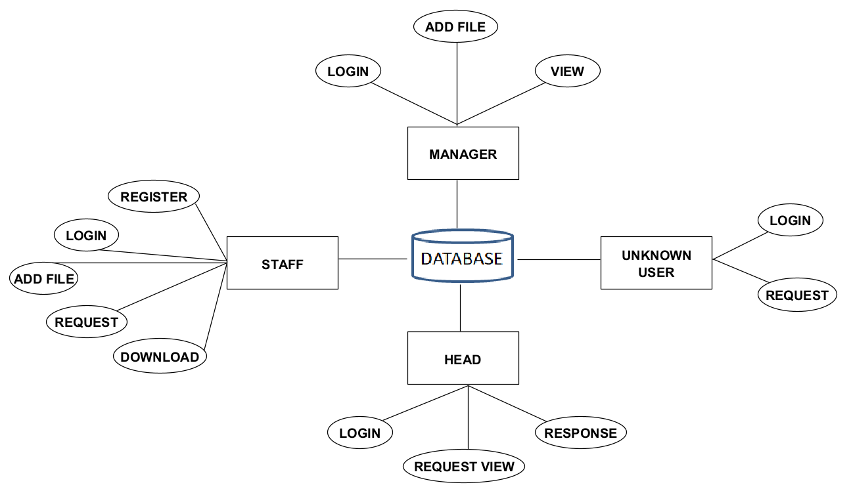

Fig 4.1. ER Diagram

* 1. **DATA FLOW DIAGRAM**

A data flow diagram (DFD) is a graphical representation of the “flow” of data through an information system. It differs from the flowchart as it shows the data flow instead of the control flow of the program. A data flow diagram can also be used for the visualization of data processing. The DFD is designed to show how a system is divided into smaller portions and to highlight the flow of data between those parts.

DFDs make it easy to depict the business requirements of applications by representing the sequence of process steps and flow of information using a graphical representation or [visual representation](https://www.techtarget.com/searchbusinessanalytics/tip/Seven-good-data-visualization-practices-for-visual-integrity) rather than a textual description.

**Level 0:**

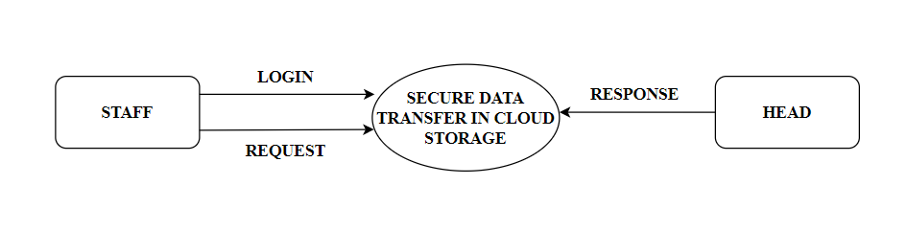

Fig 4.2. DFD Level 0

**Level 1:**

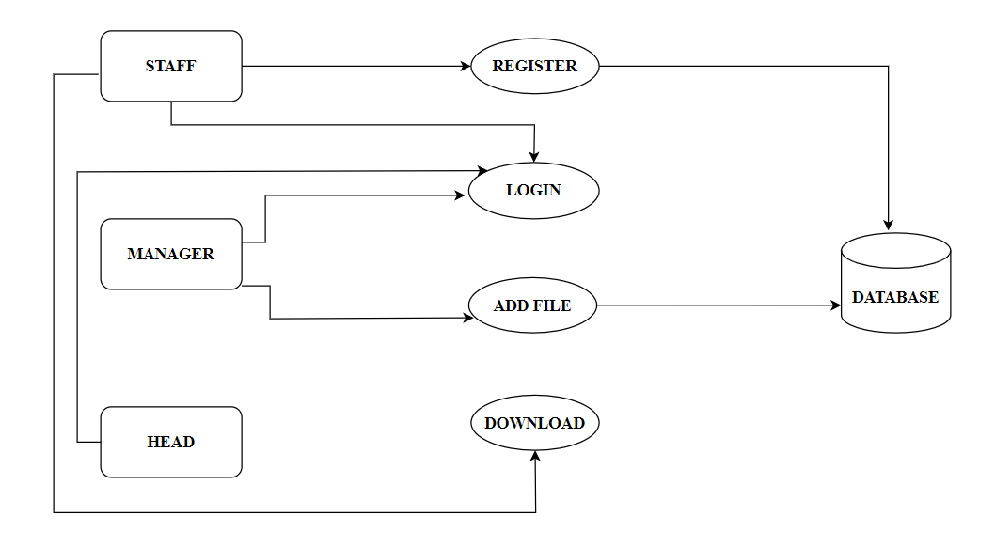

Fig 4.3. DFD Level 1

**Level 2:**

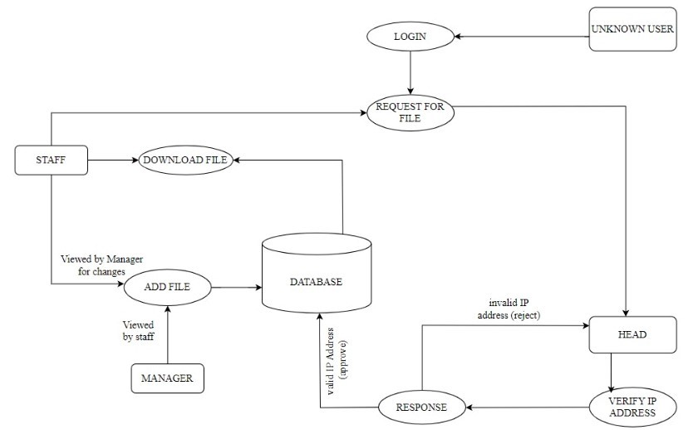

Fig 4.4. DFD Level 2

## UML DIAGRAMS

Unified Modelling Language (UML) is a general purpose modelling language. The main aim of UML is to define a standard way to visualize the way a system has been designed. UML is not a programming language, it is rather a visual language. UML is a standardized modeling language that can be used across different programming languages and development processes, so the majority of software developers will understand it and be able to apply it to their work.  There are 14 UML diagram types that help to model the behaviors.

* Structure Diagrams. Class Diagram. Component Diagram. Deployment Diagram. Object Diagram. Package Diagram. Profile Diagram. Composite Structure Diagram.
* Behavioral Diagrams. Use Case Diagram. Activity Diagram. State Machine

Diagram. Sequence Diagram. Communication Diagram. Interaction Overview Diagram.

## Use Case Diagram:

The use case diagram is the main building block of [object oriented](http://en.wikipedia.org/wiki/Object_oriented) modeling. It is used to represent the dynamic behavior of a system. It encapsulates the system's functionality by incorporating use cases, actors, and their relationships.These diagrams also identify the interactions between the system and its actors. It models the tasks, services, and functions required by a system/subsystem of an application. It depicts the high-level functionality of a system and also tells how the user handles a system.It is used both for general [conceptual modeling](http://en.wikipedia.org/wiki/Conceptual_model) of the systematic of the application, and for detailed modeling translating the models into [programming code](http://en.wikipedia.org/wiki/Programming_code).

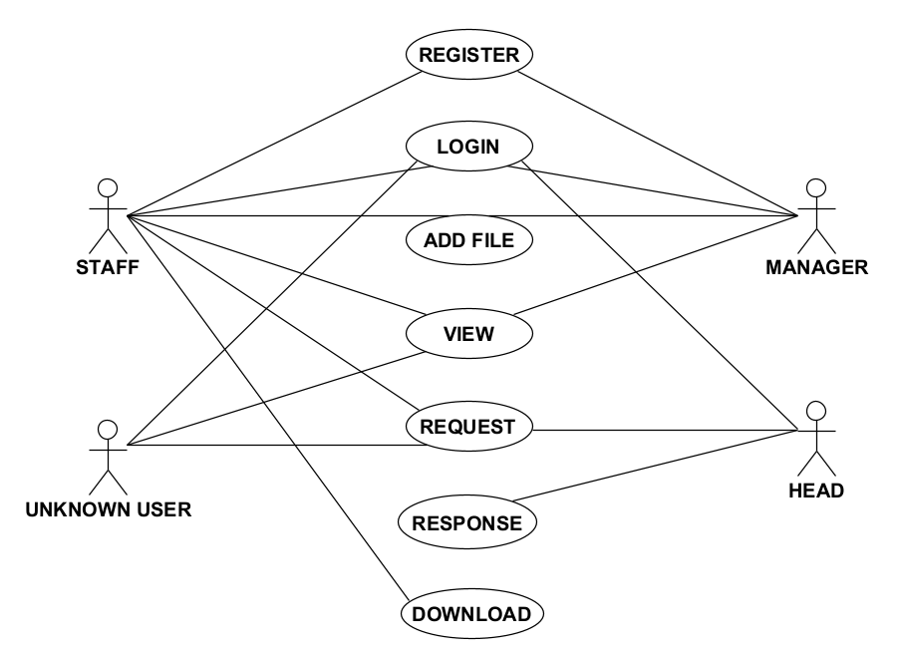

Fig 4.5. Use Case Diagram

**4.3.2. Sequence Diagram:**

A sequence diagram is a type of interaction diagram because it describes how—and in what order—a group of objects works together. It depicts the processes involved and the sequence of messages exchanged between the processes needed to carry out the functionality. These diagrams are used by software developers and business professionals to understand requirements for a new system or to document an existing process. Sequence diagrams are sometimes known as event diagrams or event scenarios. One of the primary uses of sequence diagrams is in the transition from requirements expressed as use cases to the next and more formal level of refinement. Use cases are often refined into one or more sequence diagrams.

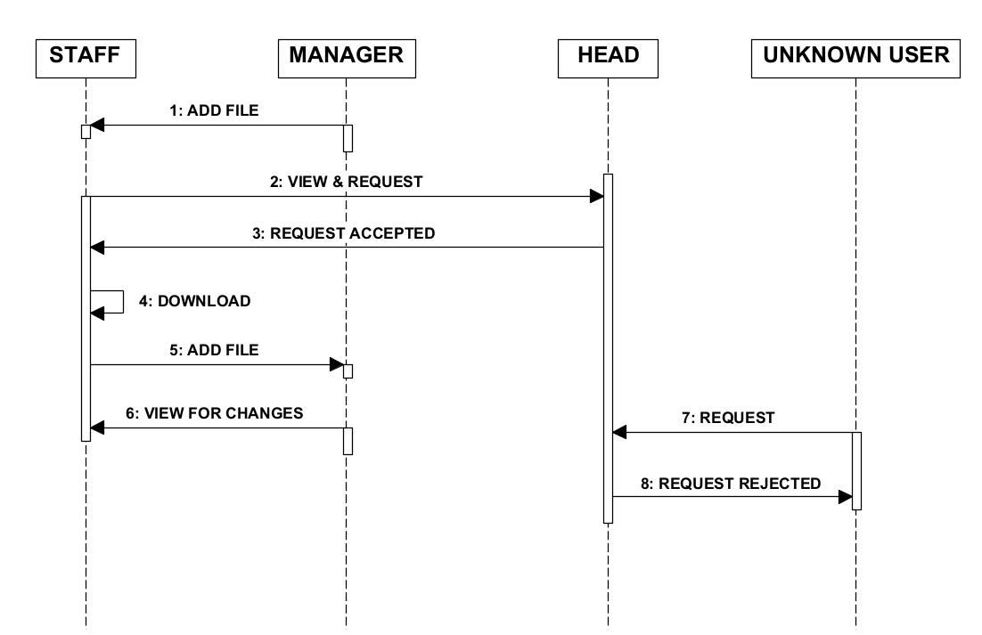

Fig 4.6. Sequence Diagram

**4.3.3. Activity Diagram:**

Activity diagram is another important diagram in UML to describe the dynamic aspects of the system. It is basically a flowchart to represent the flow from one activity to another activity. The activity can be described as an operation of the system. The control flow is drawn from one operation to another. This flow can be sequential, branched, or concurrent. Activity diagrams deal with all type of flow control by using different elements such as fork, join, etc. Activity diagrams are not only used for visualizing the dynamic nature of a system, but they are also used to construct the executable system by using forward and reverse engineering techniques.

## 

Fig 4.7. Activity Diagram

# CHAPTER 5

# SYSTEM ARCHITECTURE

## CHAPTER 5

## SYSTEM ARCHITECTURE

## ARCHITECTURE OVERVIEW

## C:\Users\GOD\Pictures\Screenshots\DSFMR\System architecture (2).jpeg

Fig 5.1. System Architecture

The design of a website page that a user can interact with is the very first point of interaction with the application through the programme. The development of the user interface uses front-end technologies. Every project needs a database or cloud storage since it controls all storage-related data and references. This project maintains and handles data pertaining in an organization. Because of this, the architecture of the databases or cloud storage calls for the storing of information starting with the staff registration and ending with the process of downloading the the file uploaded by the manager. The modules developed in the application are staff, manager, head. Initially the staff registers themselves in the organizations database and then logs in. The Staff registration is based on the IP Address of the device. Similarly the manager and the head logs in. After login the manager adds the file, which generates the secret key (i.e. the file may contain information related to projects that the organization undergoing, marketing data, employee details). The

Staff access the data by requesting to the head of the organization. The head receives the request from the staff, then the head verifies the staff IP address prior sending the secret key of the file to the staff. The staff download the file using the secret key sent by the head of the organization. And the staff will receive the secret key in the

website and through the email, then they can download the file with the secret key.

## MODULE DESIGN SPECIFICATION

|  |  |
| --- | --- |
| S.No | Module Name |
| 1 | Staff |
| 2 | Manager |
| 3 | Head |

Table 5.1. Modules

## STAFF

## Staff Register:

## The Register module gives a reasonable structure to enter information on those staff who are new to the organization. They need to sign up/register to login the website. For registeration this module requires valid input such as username, phone number, email id, password. The registration details that are filled by the staff are stored in the cloud storage.

## Staff Login:

## This module gives the way to enter into main page after login with valid input such as email id and password. The Login module is processed only if the login email id and password matches the data that are given during the registration.

## Staff File Request:

This module helps the staff, request the file stored in the cloud storage to the head and the head accept the request if the IP address is valid or else the request gets rejected if the IP address is invalid. This Request module is mainly based on the IP address of the device.

**Staff File Download:**

This module help the user to download the file after head approve the request. The file can be downloaded using Secret key. In this project we are using two secret key one is the secret key generated when the file is added and the other one is QR Code key.

**Staff Add File:**

In this module the staff adds the file to the cloud storage, which can be viewed only by the manager not by the other staff.

* + 1. **MANAGER**

**Manager Login:**

## This module gives the way to enter into main page after login with valid input such as email id and password.

## Manager Add File:

In this module the manager adds the file to the cloud storage, which can be viewed by the staff.

**Manager File View:**

In this module the manager can view the file they have uploaded.

* + 1. **HEAD**

**Head Login:**

## This module gives the way to enter into main page after login with valid input such as email id and password.

## Head Response:

This module helps the user requested file to be accepted by the head. And the unknown user or third party also request the file. But the unknown user request IP address will be verified by the head. If the IP address is valid then they will get accepted, if it is invalid then they will get rejected.

# CHAPTER 6

# SYSTEM IMPLEMENTATION

**CHAPTER 6**

**SYSTEM IMPLEMENTATION**

* 1. **ALGORITHMS**
     1. **AES (Advanced Encryption Standard)**

The AES Encryption algorithm, also referred to as the Rijndael algorithm, is a symmetric block cypher algorithm with a 128-bit block/chunk size. It uses keys of 128, 192, and 256 bits to convert each of these discrete blocks. In order to create the cipher text, it encrypts the blocks and combines them. A substitution-permutation network, or SP network, is the foundation of this system. It involves a number of interconnected processes, some of which include bit shuffles and others which involve substitutions, which are the act of changing inputs into particular outputs (permutations). When sending files in an encrypted manner between colleagues, AES is employed. Blocks of 128 bits each are used for AES encryption of data. Based on the length of the key, the number of rounds will vary as follows:

1. For 128bit key there are 10 rounds

2. For 192bit key there are 12 rounds

3. For 256bit key there are 14 rounds

**Pseudocode:**

*state = M*

*AddRoundKey(state, &w[0])*

*for i = 1 step 1 to9*

*SubBytes (state)*

*Shift Rows(state)*

*MixColumns(state)*

*AddRoundKey(state, &w[i*4])*

*end for*

*SubBytes(state)*

*Shift Rows (state)*

*Add RoundKey(state, &w[40])*

**a. Encryption:**

Each round comprises of 4 steps:

1. Sub Bytes
2. Shift Rows
3. Mix Columns
4. Add Round Key

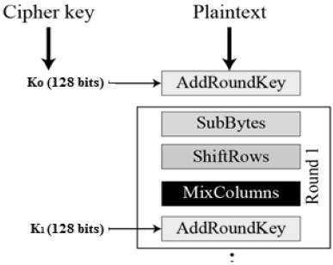

Fig 6.1. Encryption Process

**Example of Encrypting Text:**

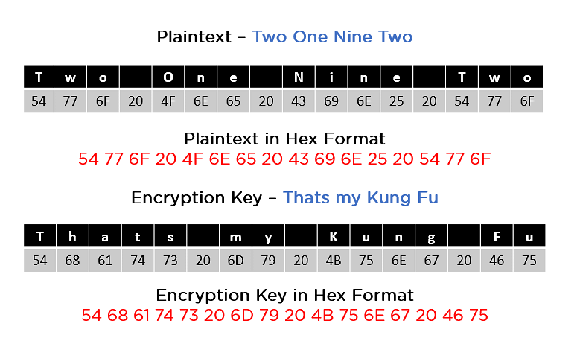

Fig 6.2. Example

In the above example the Plain text is “Two One Nine Two” and the Key is “Thats my Kung Fu” and both the plain text and key is converted into hexadecimal format.

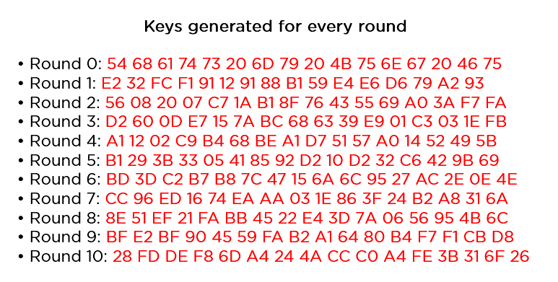

Fig 6.3. Round Key

1. **Adding Round Key:**

This is the very first round of AES encryption. Here, the algorithm adds the plain text to the key.

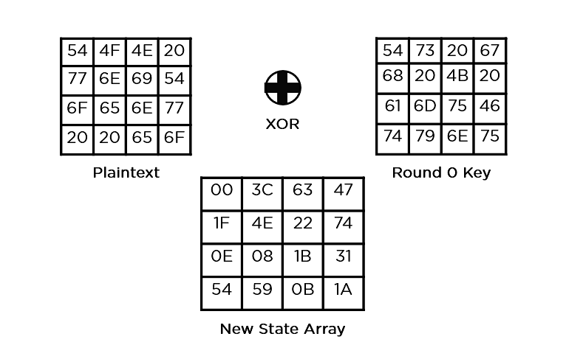

Fig 6.4. Adding Round Key

**2. Sub Bytes:**

Now, the AES algorithm substitutes every byte with a code according to a pre-established table called the Rijndael S-box. It looks like this:

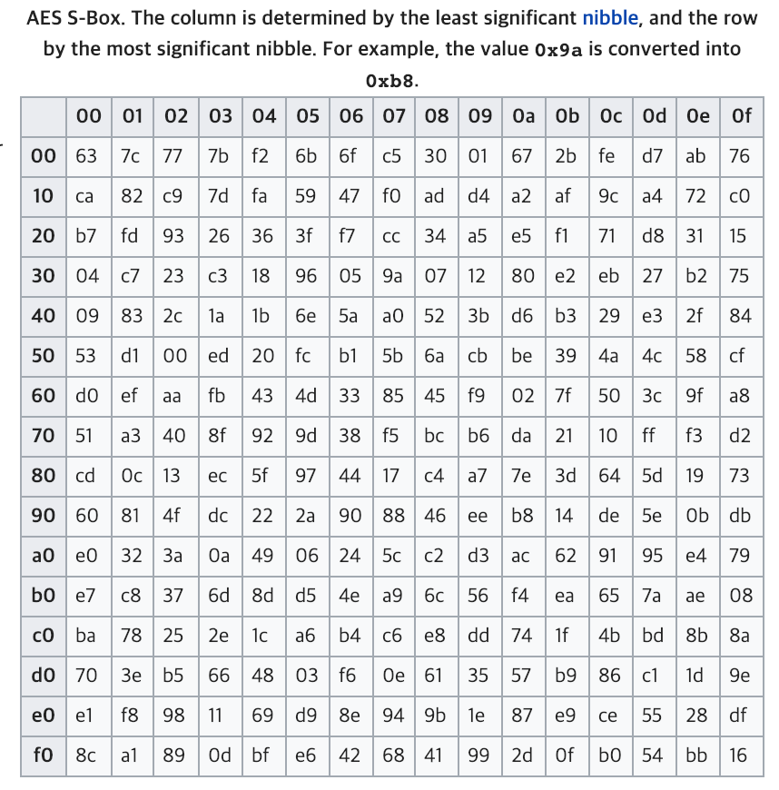

Fig 6.5. S-Box

At this stage, one byte is replaced with another. It is carried out utilizing a lookup table also known as the S-box. The state array's byte a(i,j) is replaced with a Sub Byte S(a(i,j)) in this Sub Byte step. In order to replace the sixteen input bytes, a constant table (S-box) provided in the design is looked up. The resultant is in a form of matrix with 4 rows and 4 columns.

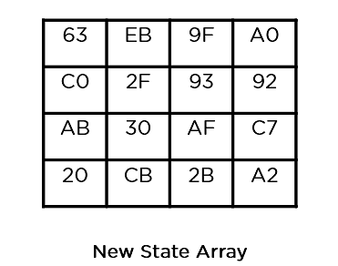

Fig 6.6. Sub Bytes

1. **Shift Rows:**

The matrix's four rows are all moved to the left. The right side of the row is used to re-insert any entries that "slip off." This is how shift is done:

1. The top row is not moved.

2. The second row has been moved left one (byte) place.

3. The third row has been moved two spaces to the left.

4. The fourth row has been moved three spaces to the left.

The outcome is a new matrix made up of the same 16 bytes but with their positions altered.

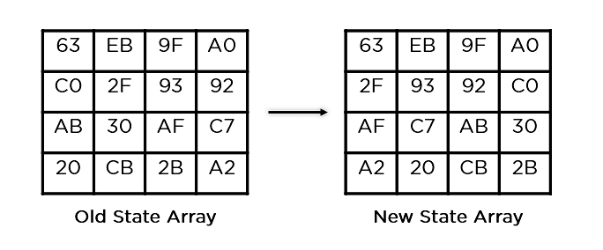

Fig 6.7. Shift Rows

1. **Mix Columns:**

A unique mathematical function is used to change each column of four bytes. The four bytes of one column are entered by this function, which returns four entirely new bytes that replace the original column. The outcome would be another new matrix with 16 more bytes. It must be noted that the final round does not include this phase.

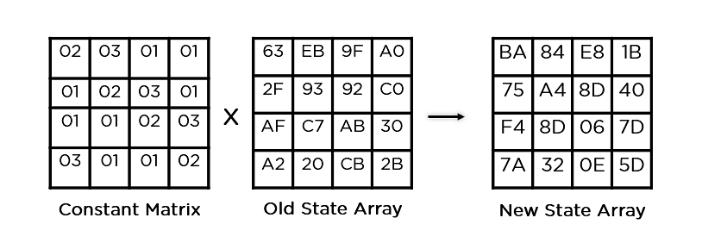

Fig 6.8. Mix columns

1. **Add Round Key:**

The 16 bytes of the matrix are now addressed as 128 bits, and they are XORed (XOR Operation) now with 128 bits of the round key. The cipher text will be produced if this is the final round. If not, the 128 bits that are produced are translated into 16 bytes, and the process starts over again.

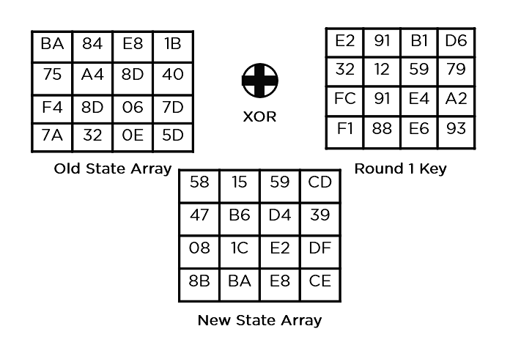

Fig 6.9. Add Round Key

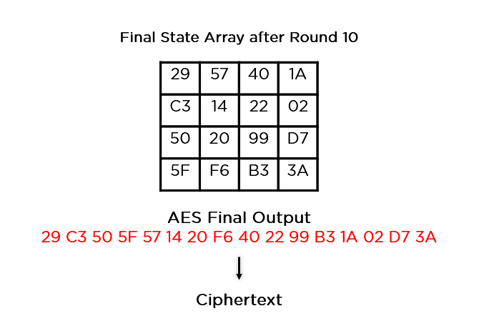

Fig 6.10. Final Output

**b. Decryption:**

An AES cipher text's decryption procedure is quite identical to its encryption procedure in reverse. The four stages are carried out in reverse order with each round.

1. Add round key

2. Mix columns

3. Shift rows

4. Byte substitution

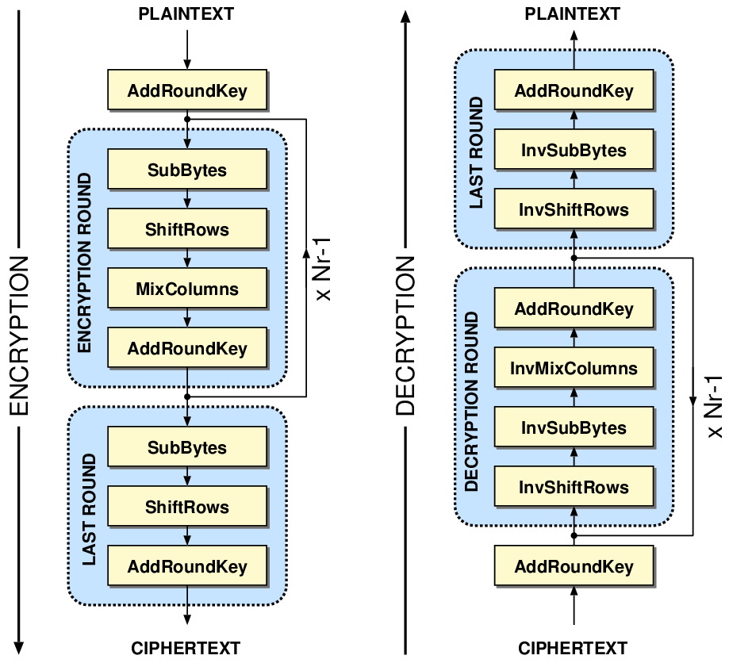

Fig 6.11. AES Architecture

* + 1. **SHA-256 (Secure Hash Algorithm – 256)**

Secure Hash Algorithm, or SHA, is the name of the family of algorithms that includes SHA 256. The 256 in the name indicates that no matter how large the plaintext or clear text is, the hash result will always be 256 bits. During the execution of the SHA-256 algorithm, a piece of data is transmitted via a function that applies mathematical operations to the plaintext. The hash function produces the hash value/digest, which is referred to as its output. In contrast to certain other well-known hashing algorithms, SHA-256 is secure and has not been "broken," which is the main reason why technology employs it. Also, it has no known flaws that would make it unstable. The hash value is always 256 bits no matter how big the clear text or plaintext is. The number 256, which is used in the name to denote the very last hash digest value, has this meaning.

**Hashing:**

A hash value, also known as a hash function, is produced by a mathematical operation and an arbitrary-sized file, such as an email, document, picture, or other type of data. As a one-way function that is specific to the file being hashed, a derived hash cannot be reversed to find more files that would provide the same hash result.

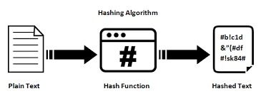

Fig 6.12. Hashing

**Characteristics of SHA-256 Algorithm:**

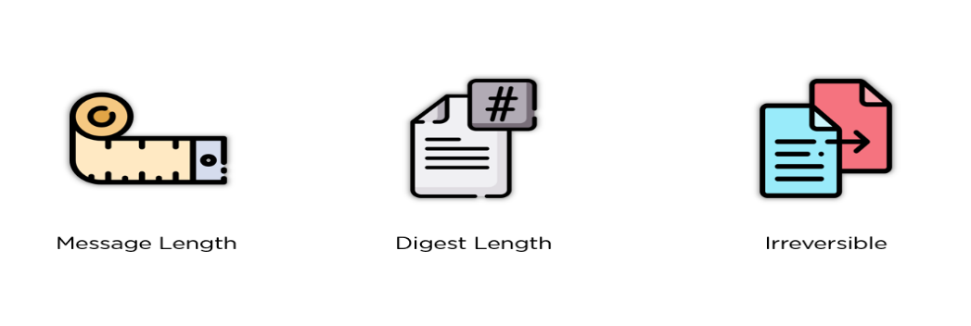

Fig 6.13. Characteristics of SHA-256

* Message Length: The clear text's length should be no more than 264 bits. To maintain the highest level of randomness in the digest, the size has to fit the comparison area.
* Digest Length: The hash digest for the SHA-256 algorithm must be 256 bits long, for the SHA-512 algorithm 512 bits, etc. Huge digests often represent a large increase in calculations at the expense of storage and efficiency.
* Irreversible: Every hash function, including SHA 256, is irreversible by design. If you have created the digest already, neither you nor the digest should receive the original cost when you run it by the hash function once more.

**Pseudocode:**

*Initialize hash values*

*Initialize array of round constants*

*Preprocessing*

*Process the message in successive 512-bit chunks*

*Initialize working variables to current hash value*

*Compression function main loop*

*Add the compressed chunk to the current hash value*

*Produce the final hash value*

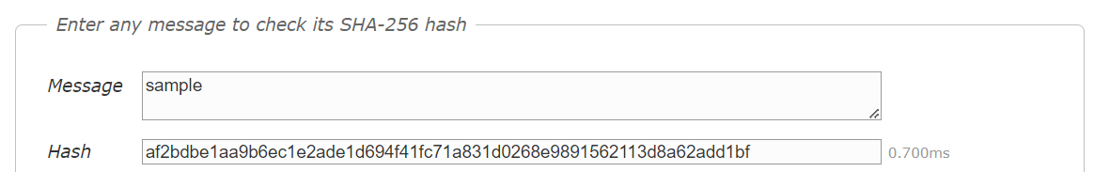

Fig 6.14. Example of Hashing

Here message is padded to ensure that its length is a multiple of 512 bits (64 bytes). The padded message is divided into 512-bit (64-byte) blocks, which are then processed in 64 rounds.

**Steps in SHA-256 Algorithm:**

1. **Padding Bits:**

In order to make our original message's length match the minimum length needed for the hash function, the first step of the hashing function is attaching bits to it. The message is given a few more bits, leaving the length exactly 64 bits shy of a factor of 512. The initial bit of the addition should be a one, and the following bits should all be zeros.

M + P + 64 = n x 512

(i.e) M = length of original message

P = padded bits

n = constant

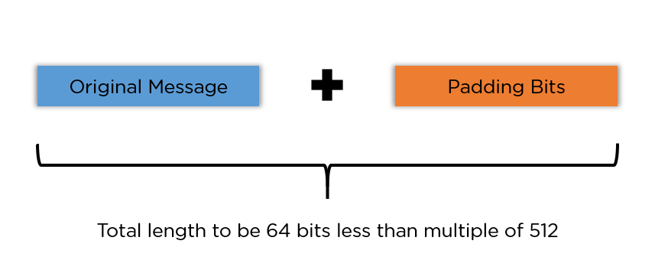

Fig 6.15. Padding Bits

1. **Padding Length:**

The resultant plaintext is then multiplied by 64 bits to make it a factor of 512.

Using the modulus of the original clear text without the padding, the 64 bits of characters are calculated.

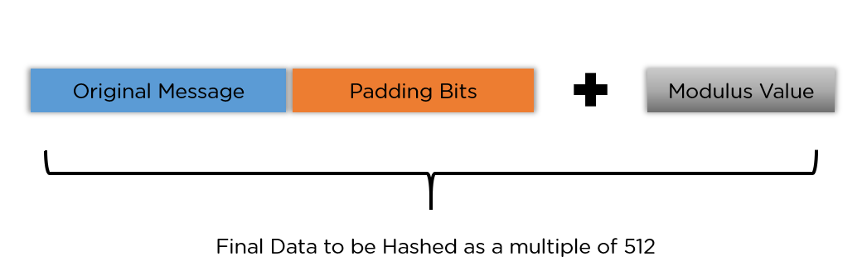

Fig 6.16. Padding Length

1. **Initialize Buffer:**

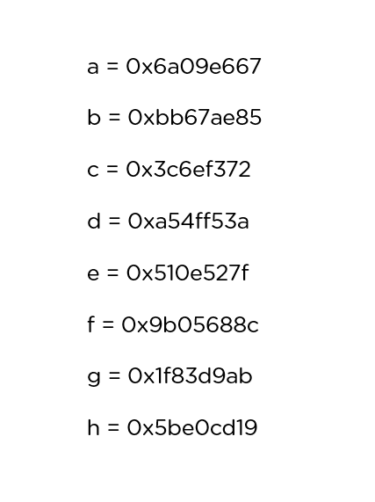 A 64-key array (K[0] to K[63]) with eight buffers each holding a default value is initialized.

Fig 6.17. Initial Buffer

1. **Compression Function:**

The algorithm divides the whole message into many blocks, each of 512 bits. The output of each block serves as the input for the subsequent block during each block's 64 rounds of execution. As a result, after each iteration, the block's final output is used as the input for the subsequent block. When you get to the final 512-bit block, you consider the output of the entire cycle to be the overall hash digest. According to the name of this algorithm, this digest will have a length of 256 bits.

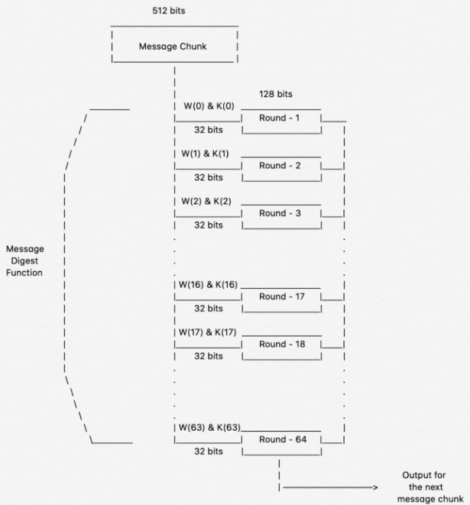

Fig 6.18. Compression Function

**Application of SHA-256:**

* Digital Signature Verification
* Password Hashing
* SSL Handshake
* Integrity Checks

# CHAPTER 7

# PERFORMANCE ANALYSIS

# CHAPTER 7

# PERFORMANCE ANALYSIS

* 1. **WEB TESTING**

A web testing process is a well-defined and organized method that enables Quality Assurance teams to ensure fast and efficient test cases for their websites and applications. For web-based application testing or software application testing, they can rely on automation which reduces the burden of repetitive and routine tasks. It is employed to ensure Cross Browser Compatibility, Responsiveness as well as ensure Security. Broken Links in the (SEO) Search Engine Optimization as well as Cookie Testing are verified through this testing. In this testing, the following technique may be performed depending on the web testing requirements.

1. **Functionality Testing of a Website:**

Functionality testing of a Website is a process that includes several testing parameters like user interface, APIs, database testing, security testing, client and server testing and basic website functionalities. It is very convenient and it allows users to perform both manual and automated testing. It is performed to test the functionalities of each feature on the website.

1. **Usability testing**:

[Usability testing](https://www.guru99.com/usability-testing-tutorial.html) has now become a vital part of any web based project. It can be **carried out by testers** like you **or a small focus group** similar to the target audience of the web application.

1. **Interface Testing:**

Three areas to be tested in this interface testing such as Application, Web and Database Server.

* Application: Test requests are sent correctly to the Database and output at the client side is displayed correctly. Errors if any must be caught by the application and must be only shown to the administrator and not the end user.
* Web Server: Test Web server is handling all application requests without any service denial.
* Database Server: Make sure queries sent to the database give expected results.

1. **Database Testing:**

Database is one of the critical components in web application. Testing activities will include:

* Test if any errors are shown while executing queries.
* Data Integrity is maintained while creating, updating or deleting data in database.
* Check response time of queries and fine tune them if necessary.
* Test data retrieved from your database is shown accurately in your web application.

1. **Compatibility testing:**

Compatibility tests ensures that your web application displays correctly across different devices. This would include:-**Browser Compatibility Test**: Same website in different browsers will display differently. You need to test if your web application is being displayed correctly across browsers, JavaScript, AJAX and authentication is working fine. You may also check for[Mobile](https://www.guru99.com/mobile-testing.html)Browser Compatibility.

1. **Performance Testing:**

This will ensure your site works under all loads. Software testing activities will include but not limited to:

* Website application response times at different connection speeds.
* Load test your web application to determine its behaviour under normal and peak loads.
* Test if a crash occurs due to peak load, how does the site recover from such an event.
* Make sure optimization techniques like zip file compression, browser and server side cache enabled to reduce load times.

1. **Security testing:**

[Security testing](https://www.guru99.com/what-is-security-testing.html) is vital for e-commerce website that store sensitive customer information like credit cards. Testing Activities will include-

* Test unauthorized access to secure pages should not be permitted.
* Restricted files should not be downloadable without appropriate access.
* Check sessions are automatically killed after prolonged user inactivity.
* On use of SSL certificates, website should re-direct to encrypted SSL pages.
  1. **TEST CASES & REPORTS**

**Module Name: Staff**

|  |  |  |  |  |  |
| --- | --- | --- | --- | --- | --- |
| **Test Case Id** | **Test Cases**  **Name** | **Input** | **Expected Output** | **Actual Output** | **Test Result**  **(Pass/Fail)** |
| TC01 | Registration | Username,  Phone number, Email ID, Password, | User should be redirected to login page  (Scr 2.2) | User should be redirected to login page  (Scr 2.2) | Pass |
| TC02 | Login | Email, Password | Login Successful  (Scr 2.3) | Login Successful  (Scr 2.3) | Pass |
| TC03 | Request | File | Request sent to Head  (Scr 2.5) | Request sent to Head  (Scr 2.5) | Pass |
| TC04 | Download | File Key, QR Code Key | Downloaded Successfully  (Scr 2.6) | Downloaded Successfully  (Scr 2.6) | Pass |

**Module Name: Manager**

|  |  |  |  |  |  |
| --- | --- | --- | --- | --- | --- |
| **Test Case Id** | **Test Cases**  **Name** | **Input** | **Expected Output** | **Actual Output** | **Test Result**  **(Pass/Fail)** |
| TC01 | Login | Email, Password | Login Successful  (Scr 2.9) | Login Successful  (Scr 2.9) | Pass |
| TC02 | Add File | File, Type | Uploaded Successfully  (Scr 2.11) | Uploaded Successfully  (Scr 2.11) | Pass |
| TC03 | View | View File | Available Files are shown  (Scr 2.13) | Available Files are shown  (Scr 2.13) | Pass |

**Module Name: Head**

|  |  |  |  |  |  |
| --- | --- | --- | --- | --- | --- |
| **Test Case Id** | **Test Cases**  **Name** | **Input** | **Expected Output** | **Actual Output** | **Test Result**  **(Pass/Fail)** |
| TC01 | Login | Email, Password | Login Successful  (Scr 2.14) | Login Successful  (Scr 2.14) | Pass |
| TC02 | Response | Verify IP Address | Request Accepted  (Scr 2.16) | Request Accepted  (Scr 2.16) | Pass |

# CHAPTER 8

# CONCLUSION

**CHAPTER 8**

**CONCLUSION**

* 1. **CONCLUSION**

Several sectors, including machine learning, banking, and the military, are utilizing blockchain, a new technology. It also has some restrictions, such as immutability for some applications where information needs to be altered. Despite these limitations, we must accept and promote its widespread adoption across a range of industries. Users share a significant amount of data daily. In this paper, we offered a more secure way to share files and store them on a reliable platform like blockchain. This technique can partially eliminate all the drawbacks of having a centralized network for sharing confidential files within an organization. Sensitive information needs to be shielded from unauthorized access. We looked into how blockchain addresses the challenging requirements of security, storage, sharing, and authentication when examining data. Cloud storage with blockchain technology seems to be a smart solution for business organization.

* 1. **FUTURE ENHANCEMENTS**

As a future work of this project we can make access for the head to view what type of file content the staff wants to download rather than verifying their IP Address. The unknown user IP Address can be blocked as well as the staff who is sharing the file content in an illegal manner can also be blocked.

**APPENDICES**

**APPENDICES**

**Appendix 1. CODING**

**1.1. CLIENT-SIDE CODING**

**homepageipspoof.jsp**

<%@ page language="java" contentType="text/html; charset=ISO-8859-1"

pageEncoding="ISO-8859-1"%>

<!DOCTYPE html PUBLIC "-//W3C//DTD HTML 4.01 Transitional//EN" "http://www.w3.org/TR/html4/loose.dtd">

<html>

<head>

<meta http-equiv="Content-Type" content="text/html; charset=ISO-8859-1">

<title>Ipspoofing Homepage</title>

<link rel="stylesheet" href="css/bootstrap.min.css">

<style>

ul {

list-style-type: none;

margin: 0;

padding: 0;

overflow: hidden;

background-color: #b3003b;

}

li {

float: right;

padding-right:185px;

}

li a {

display: block;

color: white;

text-align: center;

text-style:bold;

padding: 14px 16px;

text-decoration: none;

}

body {

background-image: url("bgimages/spoof2.jpg");

background-repeat: no-repeat;

background-size: cover;

}

</style>

</head>

<body>

<ul>

<!-- <li><a href="hackerlogin.jsp">Hacker</a></li> -->

<li><a href="headlogin.jsp">Head</a></li>

<li><a href="managerlogin.jsp">Manager</a></li>

<li><a href="stafflogin.jsp">Staff</a></li>

</ul>

</body>

</html>

**stafflogin.jsp**

<%@ page language="java" contentType="text/html; charset=ISO-8859-1"

pageEncoding="ISO-8859-1"%>

<!DOCTYPE html PUBLIC "-//W3C//DTD HTML 4.01 Transitional//EN" "http://www.w3.org/TR/html4/loose.dtd">

<html>

<head>

<meta http-equiv="Content-Type" content="text/html; charset=ISO-8859-1">

<title>Staff Login Page</title>

<link rel="stylesheet" href="css1/bootstrap.min.css">

<style>

.mydiv2{

width:300px;

height:300px;

margin-top:-250px;

margin-left:700px;

}

body {

background-image: url("bgimages/6.jpg");

background-repeat: no-repeat;

background-size: cover;

}

a {

background-color: #33ccff;

color: white;

padding: 10px 20px;

text-align: center;

text-decoration: none;

display: inline-block;

border-radius:5px;

}

/* .first{

color:#fff;

font-size:18px;

}

*/

h3{

font-family: Courier New;

color:#66d9ff;

font-style:bold;

font-size:30px;

}

.mydiv3{

font-size:30px;

color:#fff;

}

form{

width:340px;

height:400px;

background:linear-gradient(to bottom, #ff5050 0%, #99ccff 100%);

margin:100px;

margin-radius:5px;

opacity:0.9;

}

</style>

</head>

<body>

<center>

<form action="Staffloginservlet" method="post">

<br>

<h3><i>Staff Login</i></h3>

<input type="hidden" name="ipadd" placeholder="Username" style="width:230px;height:30px;border-radius:6px;text-align:center;"><br><br>

<input type="email" name="username" placeholder="Email" style="width:230px;height:30px;border-radius:6px;text-align:center;"><br><br>

<input type="password" name="password" placeholder="Password" style="width:230px;height:30px;border-radius:6px;text-align:center;"><br><br>

<input type="submit" value="Login" name="Submit" style="width:100px;height:35px;border-radius:6px;text-align:center; background-color:#408000;color:white;"><br><br>

<div class="mydiv3">NewUser?</div><a href="staffregister.jsp">Signup</a>

</form>

</center>

</body>

</html>

**staffmainpage.jsp**

<%@ page language="java" contentType="text/html; charset=ISO-8859-1"

pageEncoding="ISO-8859-1"%>

<!DOCTYPE html PUBLIC "-//W3C//DTD HTML 4.01 Transitional//EN" "http://www.w3.org/TR/html4/loose.dtd">

<html>

<head>

<meta http-equiv="Content-Type" content="text/html; charset=ISO-8859-1">

<title>Staff Home page</title>

<style>

ul {

list-style-type: none;

margin: 0;

padding: 0;

overflow: hidden;

background-color:#b3003b;

}

li {

float: right;

padding-right:105px;

}

li a {

display: block;

color:white;

text-align: center;

text-style:bold;

padding: 14px 16px;

font-size:20PX;

text-decoration: none;

}

body {

background-image: url("bgimages/3.jpeg");

background-repeat: no-repeat;

background-size:cover;

}

</style>

</head>

<body>

<ul>

<li><a href="homepageipspoof.jsp">Logout</a></li>

<li><a href="userdownload.jsp">Download</a></li>

<li><a href="userrequest.jsp">Request</a></li>

<li> <a href="Staffadd.jsp">Add file</a></li>

<li> <a href="tldes.jsp">Manager description</a></li>

<li><a href="homepageipspoof.jsp">Home</a></li>

</ul>

</body>

</html>

**managermainpage.jsp**

<%@ page language="java" contentType="text/html; charset=ISO-8859-1"

pageEncoding="ISO-8859-1"%>

<!DOCTYPE html PUBLIC "-//W3C//DTD HTML 4.01 Transitional//EN" "http://www.w3.org/TR/html4/loose.dtd">

<html>

<head>

<meta http-equiv="Content-Type" content="text/html; charset=ISO-8859-1">

<title>Manager Home Page</title>

<link rel="stylesheet" href="css/bootstrap.min.css">

<style>

ul {

list-style-type: none;

margin: 0;

padding: 0;

overflow: hidden;

background-color: #b3003b;

}

li {

float: right;

padding-right:105px;

}

li a {

display: block;

color: white;

text-align: center;

text-style:bold;

padding: 14px 16px;

text-decoration: none;

}

body {

background-image: url("bgimages/1.jpg");

background-repeat: no-repeat;

background-size: 1520px 700px;

}

</style>

</head>

<body>

<ul>

<li><a href="homepageipspoof.jsp">Logout</a></li>

<li><a href="managerfileview.jsp">View</a></li>

<li><a href="manageradd.jsp">Add</a></li>

<li><a href="homepageipspoof.jsp">Home</a></li>

<li><a href="staffsview.jsp">Staff description</a></li>

</ul>

</body>

</html>

**headmainpage.jsp**

<%@ page language="java" contentType="text/html; charset=ISO-8859-1"

pageEncoding="ISO-8859-1"%>

<!DOCTYPE html PUBLIC "-//W3C//DTD HTML 4.01 Transitional//EN" "http://www.w3.org/TR/html4/loose.dtd">

<html>

<head>

<meta http-equiv="Content-Type" content="text/html; charset=ISO-8859-1">

<title>Head office Home page</title>

<link rel="stylesheet" href="css/bootstrap.min.css">

<style>

ul {

list-style-type: none;

margin: 0;

padding: 0;

overflow: hidden;

background-color: #b3003b;

}

li {

float: right;

padding-right:105px;

}

li a {

display: block;

color: white;

text-align: center;

text-style:bold;

padding: 14px 16px;

text-decoration: none;

}

body {

background-image: url("bgimages/spoof10.jpg");

background-repeat: no-repeat;

background-size: cover;

}

</style>

</head>

<body>

<ul>

<li><a href="homepageipspoof.jsp">Logout</a></li>

<li><a href="headrespons.jsp">Response</a></li>

<li><a href="homepageipspoof.jsp">Home</a></li>

</ul>

</body>

</html>

**manageradd.jsp**

<%@ page language="java" contentType="text/html; charset=ISO-8859-1"

pageEncoding="ISO-8859-1"%>

<%@page import="java.util.*" %>

<!DOCTYPE html PUBLIC "-//W3C//DTD HTML 4.01 Transitional//EN" "http://www.w3.org/TR/html4/loose.dtd">

<html>

<head>

<meta http-equiv="Content-Type" content="text/html; charset=ISO-8859-1">

<title>Add file</title>

<link rel="stylesheet" href="css1/bootstrap.min.css">

<link rel="stylesheet" href="css/font-awesome.min1.css">

</head>

<style>

body{

background-color:#33BAFF;

}

</style>

<body><br>

<div class="backtag">

<button class="btn btn-warning" onclick="history.back()" style="float:right">Back</button>

</div>

<br><br>

<center>

<% Random r=new Random();

int f=r.nextInt(100000);

String filekey= ""+f;

%>

<%

Random r1=new Random();

String key2="ABCDEFGH123456789";

char c5=key2.charAt(r1.nextInt(key2.length()));

char c6=key2.charAt(r1.nextInt(key2.length()));

char c7=key2.charAt(r1.nextInt(key2.length()));

char c8=key2.charAt(r1.nextInt(key2.length()));

char c9=key2.charAt(r1.nextInt(key2.length()));

String t6=""+c5+""+c6+""+c7+""+c8+""+c9;

%>

<br><br>

<div class="container">

<h3 style="font-weight: bold; text-align: center;margin-top: 10px">Add File</h3><br>

<form method="post" action="Manageraddservlet" enctype="multipart/form-data">

<div class="row">

<div class="card col-sm-5" style="padding-bottom:10px;background-color: #333;color:#fff;padding:10px;margin-left:30%;width: 38em;margin-bottom: 25px">

<div class="form-group">

<label for="full_name" style="color:#fff;">File Key:</label>

<input type="text" class="form-control" id="full_name" value=<%=t6%> name="filekey" required>

</div>

<div class="form-group">

<label for="card_photo" style="color:#fff;">Upload your File:</label>

<input type="file" class="form-control" placeholder="Enter password" name="photo" accept="image/*" onchange="preview_image(event)" required>

</div>

<div class="form-group">

<label for="email" style="color:#fff;">Type:</label>

<select name="category" class="form-control" id="email" required>

<option value="Marketing data">Marketing data</option>

<option value="Product data">Product data</option>

<option value="Project details">Project details</option>

<option value="Software data">Software data</option>

<option value="Management">Management</option>

<option value="Sales data">Sales data</option>

<option value="Employee details">Employee details</option>

</select>

</div>

<div class="form-check">

<label for="flexRadioDefault1" style="color:#fff;">Priority:</label>

<input type="radio" name="priority" value="high">High

<input type="radio" name="priority" value="low">Low

<input type="radio" name="priority" value="medium">Medium

</div><br>

<center><button class="btn btn-primary btn-block" style="width:50%;" onclick="return Validate()">Submit</button></center><br>

</table>

</div>

</div>

</form>

</center>

</body>

</html>

**userrequest.jsp**

<%@ page language="java" contentType="text/html; charset=ISO-8859-1"

pageEncoding="ISO-8859-1"%>

<%@page import="dbconn.Dbconn"%>

<%@page import="java.sql.ResultSet"%>

<%@page import="java.sql.PreparedStatement" %>

<%@page import="java.sql.*" %>

<%@page import="java.util.*" %>

<!DOCTYPE html PUBLIC "-//W3C//DTD HTML 4.01 Transitional//EN" "http://www.w3.org/TR/html4/loose.dtd">

<html>

<head>

<meta http-equiv="Content-Type" content="text/html; charset=ISO-8859-1">

<title>Staff request</title>

<link rel="stylesheet" href="css/bootstrap.min.css">

<style>

ul {

list-style-type: none;

margin: 0;

padding: 0;

overflow: hidden;

background-color: #0000ff;

}

li {

float: right;

padding-right:95px;

}

li a {

display: block;

color: white;

text-align: center;

text-style:bold;

padding: 14px 16px;

text-decoration: none;

}

.backtag{

float:right;

margin-right:50px;

font-size:15px;

}

.myDiv2 {

font-size:25px;

font-style: italic;

font-weight: bold;

color:blue;

}

table,td,th {

border: 2px solid black;

}

table {

border-collapse: collapse;

width: 90%;

}

td {

text-align: center;

height: 40px;

}

th{

height: 30px;

color: blue;

}

a{

background-color: #f44336;

color: white;

padding: 10px 15px;

text-align: center;

text-decoration: none;

display: inline-block;

border-radius:8px;

}

</style>

</head>

<body>

<!-- <ul>

<li><a href="ownermainpage.jsp">Logout</a></li>

</ul>

-->

<div class="backtag">

<a href="staffmainpage.jsp">Back</a>

</div>

<br>

<center>

<div class="myDiv2">

Staff Viewlist

</div>

<%

String idlist="";

String fnamelist="";

String fkeylist="";

String encryptlist="";

String categlist="";

String priorlist="";

String ipadds="";

%>

<%

String emails=session.getAttribute("emailkey").toString();

//String ipadds=session.getAttribute("ipaddkey").toString();

%>

<%

Connection d2 = Dbconn.create();

PreparedStatement p2 = d2.prepareStatement("SELECT * FROM `ipspoof`.`userregistertbl` where email='"+emails+"'");

ResultSet rp2 = p2.executeQuery();

while (rp2.next()){

/* idlist=rp.getString(1);

fnamelist=rp.getString(2);

fkeylist=rp.getString(3);

encryptlist=rp.getString(4);

categlist=rp.getString(5);

priorlist=rp.getString(6); */

ipadds=rp2.getString(6);

%>

<%

}

%>

<br><br><br>

<table>

<!-- <th>Pharmacyname</th> -->

<th>Username</th>

<th>Ipaddress</th>

<th>Filename</th>

<th>Content</th>

<th>Category</th>

<th>Priority</th>

<th>Remarks</th>

<%

Connection d = Dbconn.create();

PreparedStatement p = d.prepareStatement("SELECT id,filename,filekey,encrypt,categ,priority,encrypt FROM `ipspoof`.`upload2`");

ResultSet rp = p.executeQuery();

while (rp.next()){

idlist=rp.getString(1);

fnamelist=rp.getString(2);

fkeylist=rp.getString(3);

encryptlist=rp.getString(4);

categlist=rp.getString(5);

priorlist=rp.getString(6);

encryptlist=rp.getString(7);

%>

<tr>

<td><%=emails %></td>

<td><%=ipadds %></td>

<td><%=fnamelist %></td>

<td><%=rp.getString(7) %></td>

<%-- <td><%=encryptlist %> </td> --%>

<td><%=categlist %> </td>

<td><%=priorlist %> </td>

<td><a href="staffrequestjava.jsp?emaill=<%=emails %>&&ipaddl=<%=ipadds %>&&fnamel=<%=fnamelist%>&&fkeyl=<%=fkeylist%>&&fcategl=<%=categlist%>&&fpriorl=<%=priorlist%>">Request</a></td>

</tr>

<%

}

%>

</table>

</center>

</body>

</html>

**headrespons.jsp**

<%@ page language="java" contentType="text/html; charset=ISO-8859-1"

pageEncoding="ISO-8859-1"%>

<%@page import="dbconn.Dbconn"%>

<%@page import="java.sql.ResultSet"%>

<%@page import="java.sql.PreparedStatement" %>

<%@page import="java.sql.*" %>

<%@page import="java.util.*" %>

<!DOCTYPE html PUBLIC "-//W3C//DTD HTML 4.01 Transitional//EN" "http://www.w3.org/TR/html4/loose.dtd">

<html>

<head>

<meta http-equiv="Content-Type" content="text/html; charset=ISO-8859-1">

<title>Response</title>

<link rel="stylesheet" href="css/bootstrap.min.css">

<style>

ul {

list-style-type: none;

margin: 0;

padding: 0;

overflow: hidden;

background-color: #0000ff;

}

li {

float: right;

padding-right:95px;

}

li a {

display: block;

color: white;

text-align: center;

text-style:bold;

padding: 14px 16px;

text-decoration: none;

}

.backtag{

float:right;

margin-right:50px;

font-size:15px;

}

.myDiv2 {

font-size:25px;

font-style: italic;

font-weight: bold;

color:blue;

}

table,td,th {

border: 2px solid black;

}

table {

border-collapse: collapse;

width: 90%;

}

td {

text-align: center;

height: 40px;

}

th{

height: 30px;

color: blue;

}

a{

background-color: #f44336;

color: white;

padding: 10px 15px;

text-align: center;

text-decoration: none;

display: inline-block;

border-radius:8px;

}

</style>

</head>

<body>

<!-- <ul>

<li><a href="ownermainpage.jsp">Logout</a></li>

</ul>

-->

<div class="backtag">

<a href="headmainpage.jsp">Back</a>

</div>

<br>

<center>

<div class="myDiv2">

Head Office Response

</div>

<%

//String emails=session.getAttribute("emailkey").toString();

//String ipadds=session.getAttribute("ipaddkey").toString();

//String ipadds="";

%>

<br><br><br>

<table>

<!-- <th>Pharmacyname</th> -->

<th>Email</th>

<th>Ipaddress</th>

<th>Filename</th>

<th>Filekey</th>

<th>Category</th>

<th>Priority</th>

<th>Remarks</th>

<th>Reject</th>

<%

String idlist="";

String fnamelist="";

String fkeylist="";

String encryptlist="";

String categlist="";

String priorlist="";

String unamelist="";

String ipaddlist="";

%>

<%

Random r1=new Random();

String key2="ABCDEFGH123456789";

char c5=key2.charAt(r1.nextInt(key2.length()));

char c6=key2.charAt(r1.nextInt(key2.length()));

char c7=key2.charAt(r1.nextInt(key2.length()));

char c8=key2.charAt(r1.nextInt(key2.length()));

char c9=key2.charAt(r1.nextInt(key2.length()));

String t6=""+c5+""+c6+""+c7+""+c8+""+c9;

%>

<%

Connection d = Dbconn.create();

PreparedStatement p = d.prepareStatement("SELECT * FROM `ipspoof`.`request`");

ResultSet rp = p.executeQuery();

while (rp.next()){

idlist=rp.getString(1);

fnamelist=rp.getString(2);

fkeylist=rp.getString(3);

categlist=rp.getString(4);

priorlist=rp.getString(5);

unamelist=rp.getString(6);

ipaddlist=rp.getString(7);

%>

<tr>

<td><%=unamelist %></td>

<td><%=ipaddlist %></td>

<td><%=fnamelist %></td>

<td><%=fkeylist %></td>

<%-- <td><%=encryptlist %> </td> --%>

<td><%=categlist %> </td>

<td><%=priorlist %> </td>

<td><a href="headresponsjava.jsp?emaill=<%=unamelist %>&&ipaddl=<%=ipaddlist %>&&fnamel=<%=fnamelist%>&&fkeyl=<%=fkeylist%>&&fcategl=<%=categlist%>&&fpriorl=<%=priorlist%>&&fkey=<%=t6%>">Accept</a></td>

<td><a href="reject.jsp?id=<%=rp.getString(1) %>&&emaill=<%=unamelist %>&&ipaddl=<%=ipaddlist %>&&fnamel=<%=fnamelist%>&&fkeyl=<%=fkeylist%>&&fcategl=<%=categlist%>&&fpriorl=<%=priorlist%>">Reject</a></td>

</tr>

<%

}

%>

</table>

</center>

</body>

</html>

**userdownload.jsp**

<%@ page language="java" contentType="text/html; charset=ISO-8859-1"

pageEncoding="ISO-8859-1"%>

<%@page import="dbconn.Dbconn"%>

<%@page import="java.sql.ResultSet"%>

<%@page import="java.sql.PreparedStatement" %>

<%@page import="java.sql.*" %>

<%@page import="java.util.*" %>

<%@page import="servlet.Encryptdata" %>

<%@ page import="java.util.*" %>

<%@ page import="java.util.Random" %>

<%-- <%@ page import="javax.servlet.http.HttpSession" %> --%>

<!DOCTYPE html PUBLIC "-//W3C//DTD HTML 4.01 Transitional//EN" "http://www.w3.org/TR/html4/loose.dtd">

<html>

<head>

<meta http-equiv="Content-Type" content="text/html; charset=ISO-8859-1">

<meta charset="utf-8">

<meta name="viewport" content="width=device-width, initial-scale=1">

<link rel="stylesheet" href="css/bootstrap.min.css">

<script type="text/javascript" src="js/jquery.min.js"></script>

<script type="text/javascript" src="js/bootstrap.min.js"></script>

<title>QR-Code Generator</title>

<style>

body {

background-image: url("image/32.jpg");

background-repeat: no-repeat;

background-size: cover;

}

*{margin:0px; padding:0px;font-family: Helvetica, Arial, sans-serif;}

h1 { text-align: center; text-shadow: 2px 2px 0px rgba(255,255,255,.7), 5px 7px 0px rgba(0, 0, 0, 0.1); font-size:50px; margin-top:40px; color:#fff; }

input[type=text]{

width: 90%;

padding: 12px 20px;

margin: 8px 26px;

display: inline-block;

border: 1px solid #ccc;

box-sizing: border-box;

font-size:16px;

}

button {

background-color: #4CAF50;

color: white;

padding: 14px 20px;

margin: 8px 26px;

border: none;

cursor: pointer;

width: 61%;

height: 46px;

font-size:20px;

}

button:hover {

opacity: 0.8;

}

</style>

<script src="https://ajax.googleapis.com/ajax/libs/jquery/3.2.1/jquery.min.js"></script>

</head>

<%-- <%

String name=request.getSession().getAttribute("name").toString();

System.out.println("Name: "+name);

%> --%>

<body background="../background1.png">

<%String email=session.getAttribute("emailkey").toString(); %>

<div class="col-sm-2"></div>

<div class="col-sm-8">

<center>

<table class="table table-sm" style="margin-top: 100px">

<tr>

<th>Filename</th>

<th>Filekey </th>

<th>Manager Email</th>

<th>QR Generate</th>

<th>Download</th>

</tr>

<%

String sno="";

String file="";

Connection con = Dbconn.create();

PreparedStatement p = con.prepareStatement("SELECT * FROM ipspoof.respons where uname='"+email+"' ");

ResultSet rs=p.executeQuery();

while(rs.next())

{

sno=rs.getString(1);

file=rs.getString(8);

%>

<tr>

<td><%=rs.getString(2)%></td>

<td><%=rs.getString(3)%></td>

<td><%=rs.getString(6)%></td>

<td>

<% Encryptdata cd=new Encryptdata();

String fkey=cd.decrypt(file);%>

<button class="generate" onclick="myFunction(this.value)" value="<%=fkey %>">generate</button>

</td>

<td><a href="staffdownloadjava.jsp?headkey=<%=fkey %>&&fname1=<%=rs.getString(2)%>&&fkeyl=<%=rs.getString(3)%>&&headkey=<%=file %>&&email=<%=email%>"><button class="btn-btn-info btn-sm"> Download</button></a></td>

</tr>

<%}%>

</table>

</center>

</div>

<div class="col-sm-2"></div>

</center>

</div>

<h1>Staff Download Page</h1>

<div style="float:right;">

<div id="image" style="margin:auto"></div>

<div id="link" style="margin-top:10px; text-align:center"></div>

</div>

<div id="code" style="float:left; width:100%; height:20px; text-align:center; margin-top:10px"></div>

<script>

function myFunction(data) {

var size = 248;

if(data == "") {

console.log("out")

$("#alert").append("<p style='color:#fff;font-size:20px'>Please Enter A Url Or Text</p>"); // If Input Is Blank

return false;

} else {

if( $("#image").is(':empty')) {

console.log("in")

//QR Code Image

$("#image").append("<img src='http://chart.apis.google.com/chart?cht=qr&chl=" + data + "&chs=" + size + "' alt='qr' />");

//This Provide An Image Download Link

$("#link").append("<a style='color:#fff;' href='http://chart.apis.google.com/chart?cht=qr&chl=" + data + "&chs=" + size + "'>Download QR Code</a>");

//This Provide the Image Link Path In Text

// $("#code").append("<p style='color:#fff;'><strong>Image Link:</strong> http://chart.apis.google.com/chart?cht=qr&chl=" + data + "&chs=" + size + "</p>");

return true;

} else {

console.log("else out")

$("#image").html("");

$("#link").html("");

$("#code").html("");

//QR Code Image

$("#image").append("<img src='http://chart.apis.google.com/chart?cht=qr&chl=" + data + "&chs=" + size + "' alt='qr' />");

//This Provide An Image Download Link

$("#link").append("<a style='color:#fff;' href='http://chart.apis.google.com/chart?cht=qr&chl=" + data + "&chs=" + size + "'>Download QR Code</a>");

//This Provide the Image Link Path In Text

$("#code").append("<p style='color:#fff;'><strong>Image Link:</strong> http://chart.apis.google.com/chart?cht=qr&chl=" + data + "&chs=" + size + "</p>");

return false;

}

}

}

</script>

</body>

</html>

**1.2. SERVER-SIDE CODING**

**Block.java**

package bean;

import java.util.Date;

import servlet.StringUtil;

public class Block {

public String hash;

public String previousHash;

private String data; //our data will be a simple message.

private long timeStamp; //as number of milliseconds since 1/1/1970.

public Block(String data,String previousHash ) {

this.data = data;

this.previousHash = previousHash;

this.timeStamp = new Date().getTime();

this.hash = calculateHash(); //Making sure we do this after we set the other values.

}

public String calculateHash() {

String calculatedhash = StringUtil.applySha256(

previousHash +

Long.toString(timeStamp) +

data

);

return calculatedhash;

}

}

**AES.java**

package servlet;

import java.security.Key;

import javax.crypto.Cipher;

import javax.crypto.spec.SecretKeySpec;

import sun.misc.*;

public class AES

{

private static String algorithm = "AES";

private static byte[] keyValue=new byte[]

{ 'A', 'S', 'e', 'c', 'u', 'r', 'e', 'S', 'e', 'c', 'r', 'e', 't', 'K', 'e', 'y' };

// Performs Encryption

public static String encrypt99(String plainText) throws Exception

{

Key key = generateKey();

Cipher chiper = Cipher.getInstance(algorithm);

chiper.init(Cipher.ENCRYPT_MODE, key);

byte[] encVal = chiper.doFinal(plainText.getBytes());

String encryptedValue = new BASE64Encoder().encode(encVal);

return encryptedValue;

}

// Performs decryption

public static String decrypt(String encryptedText) throws Exception

{

// generate key

Key key = generateKey();

Cipher chiper = Cipher.getInstance(algorithm);

chiper.init(Cipher.DECRYPT_MODE, key);

byte[] decordedValue = new BASE64Decoder().decodeBuffer(encryptedText);

byte[] decValue = chiper.doFinal(decordedValue);

String decryptedValue = new String(decValue);

return decryptedValue;

}

**Dbconn.java**

package dbconn;

import java.sql.Connection;

import java.sql.DriverManager;

public class Dbconn {

static Connection con;

public static Connection create(){

try{

Class.forName("com.mysql.jdbc.Driver");

con=DriverManager.getConnection("jdbc:mysql://database-1.czgatqn8bdbt.ap-northeast-1.rds.amazonaws.com:3306/ipspoof","admin","abitha234");

}catch(Exception ex)

{

ex.printStackTrace();

}

return con;

}

}

**mail1.java**

package mail;

import java.util.Properties;

import javax.mail.Message;

import javax.mail.MessagingException;

import javax.mail.PasswordAuthentication;

import javax.mail.Session;

import javax.mail.Transport;

import javax.mail.internet.InternetAddress;

import javax.mail.internet.MimeMessage;

public class mail1 {

public static void send(final String from,final String password,String to,String sub,String msg){

//Get properties object

Properties props = new Properties();

props.put("mail.smtp.host", "smtp.gmail.com");

props.put("mail.smtp.socketFactory.port", "465");

props.put("mail.smtp.socketFactory.class",

"javax.net.ssl.SSLSocketFactory");

props.put("mail.smtp.auth", "true");

props.put("mail.smtp.port", "465");

//get Session

Session session = Session.getDefaultInstance(props,

new javax.mail.Authenticator() {

protected PasswordAuthentication getPasswordAuthentication() {

return new PasswordAuthentication(from,password);

}

});

//compose message

try {

MimeMessage message = new MimeMessage(session);

message.addRecipient(Message.RecipientType.TO,new InternetAddress(to));

message.setSubject(sub);

message.setText(msg);

//send message

Transport.send(message);

System.out.println("message sent successfully");

} catch (MessagingException e) {throw new RuntimeException(e);

}

}

public static void mail(String mail,String password) {

//from,password,to,subject,message

send("mailjavasend@gmail.com","vxiheforquruguxf",mail,"Approval",password);

//change from, password and to

}

public static void logmail(String mail,String password) {

//from,password,to,subject,message

send("mailjavasend@gmail.com","vxiheforquruguxf",mail,"One Time Password",password);

//change from, password and to

} }

**StringUtil.java**

package servlet;

import java.security.MessageDigest;

public class StringUtil {

//Applies Sha256 to a string and returns the result.

public static String applySha256(String input){

try {

MessageDigest digest = MessageDigest.getInstance("SHA-256");

//Applies sha256 to our input,

byte[] hash = digest.digest(input.getBytes("UTF-8"));

StringBuffer hexString = new StringBuffer(); // This will contain hash as hexidecimal

for (int i = 0; i < hash.length; i++) {

String hex = Integer.toHexString(0xff & hash[i]);

if(hex.length() == 1) hexString.append('0');

hexString.append(hex);

}

return hexString.toString();

}

catch(Exception e) {

throw new RuntimeException(e);

}

}

}

**Appendix 2. SAMPLE SCREENSHOTS**

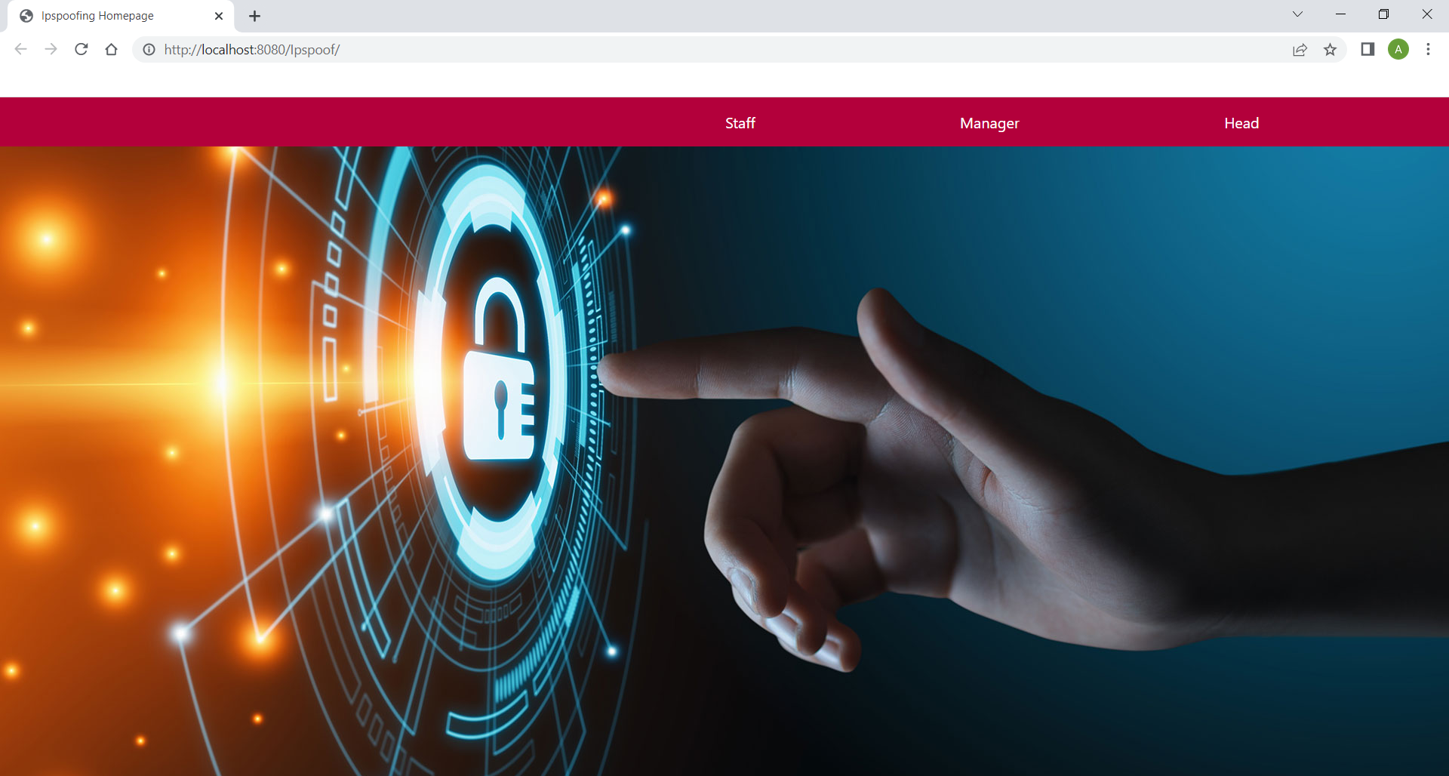

**Scr 2.1. Homepage**

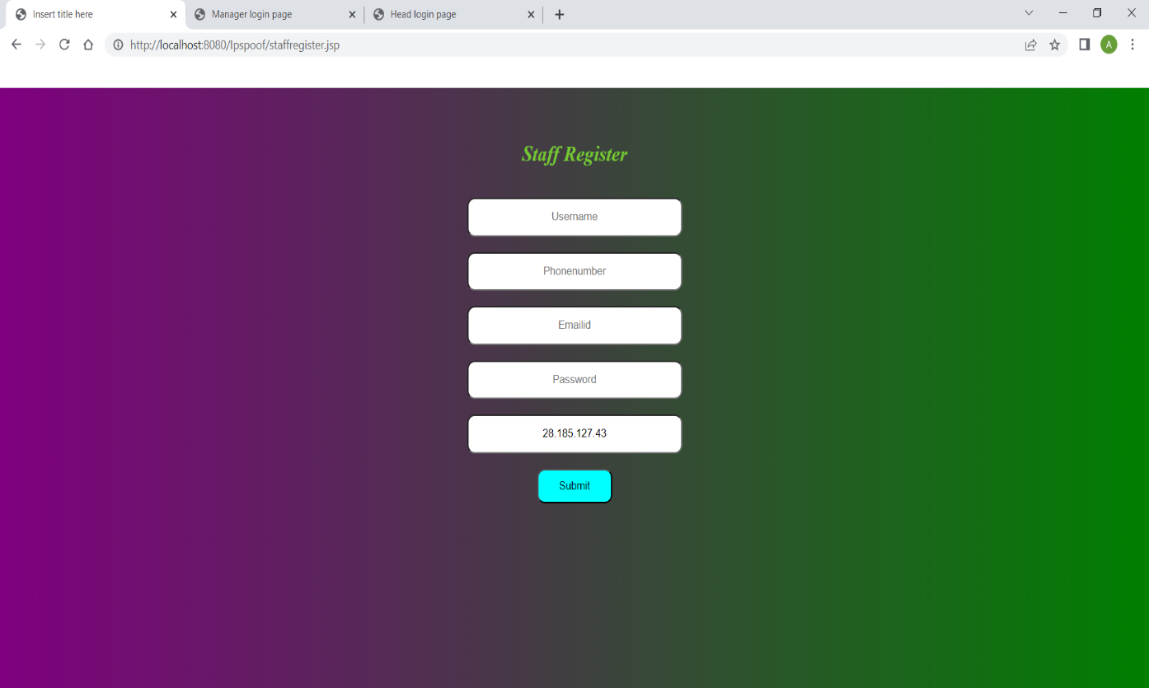

**Scr 2.2. Staff Register Page**

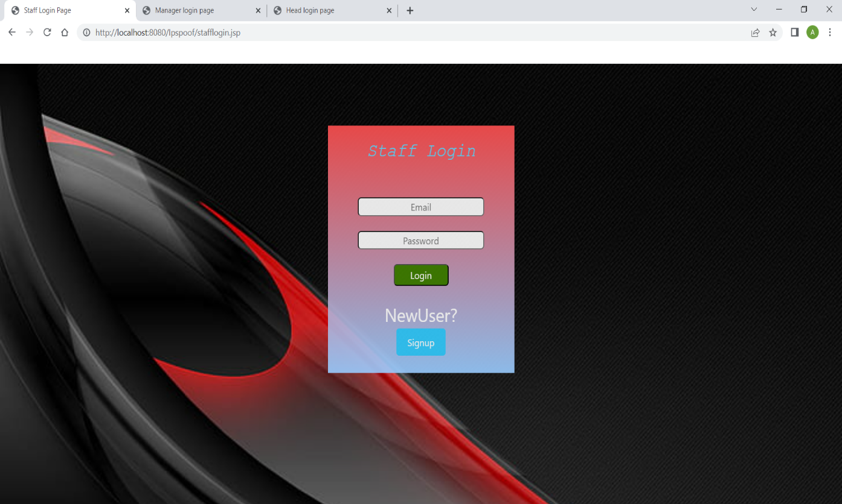

**Scr 2.3. Staff Login Page**

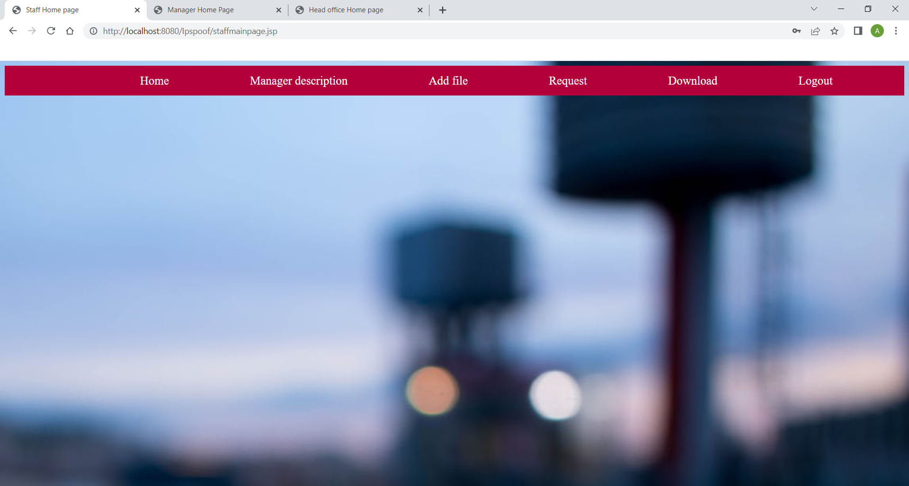

**Scr 2.4. Staff Homepage**

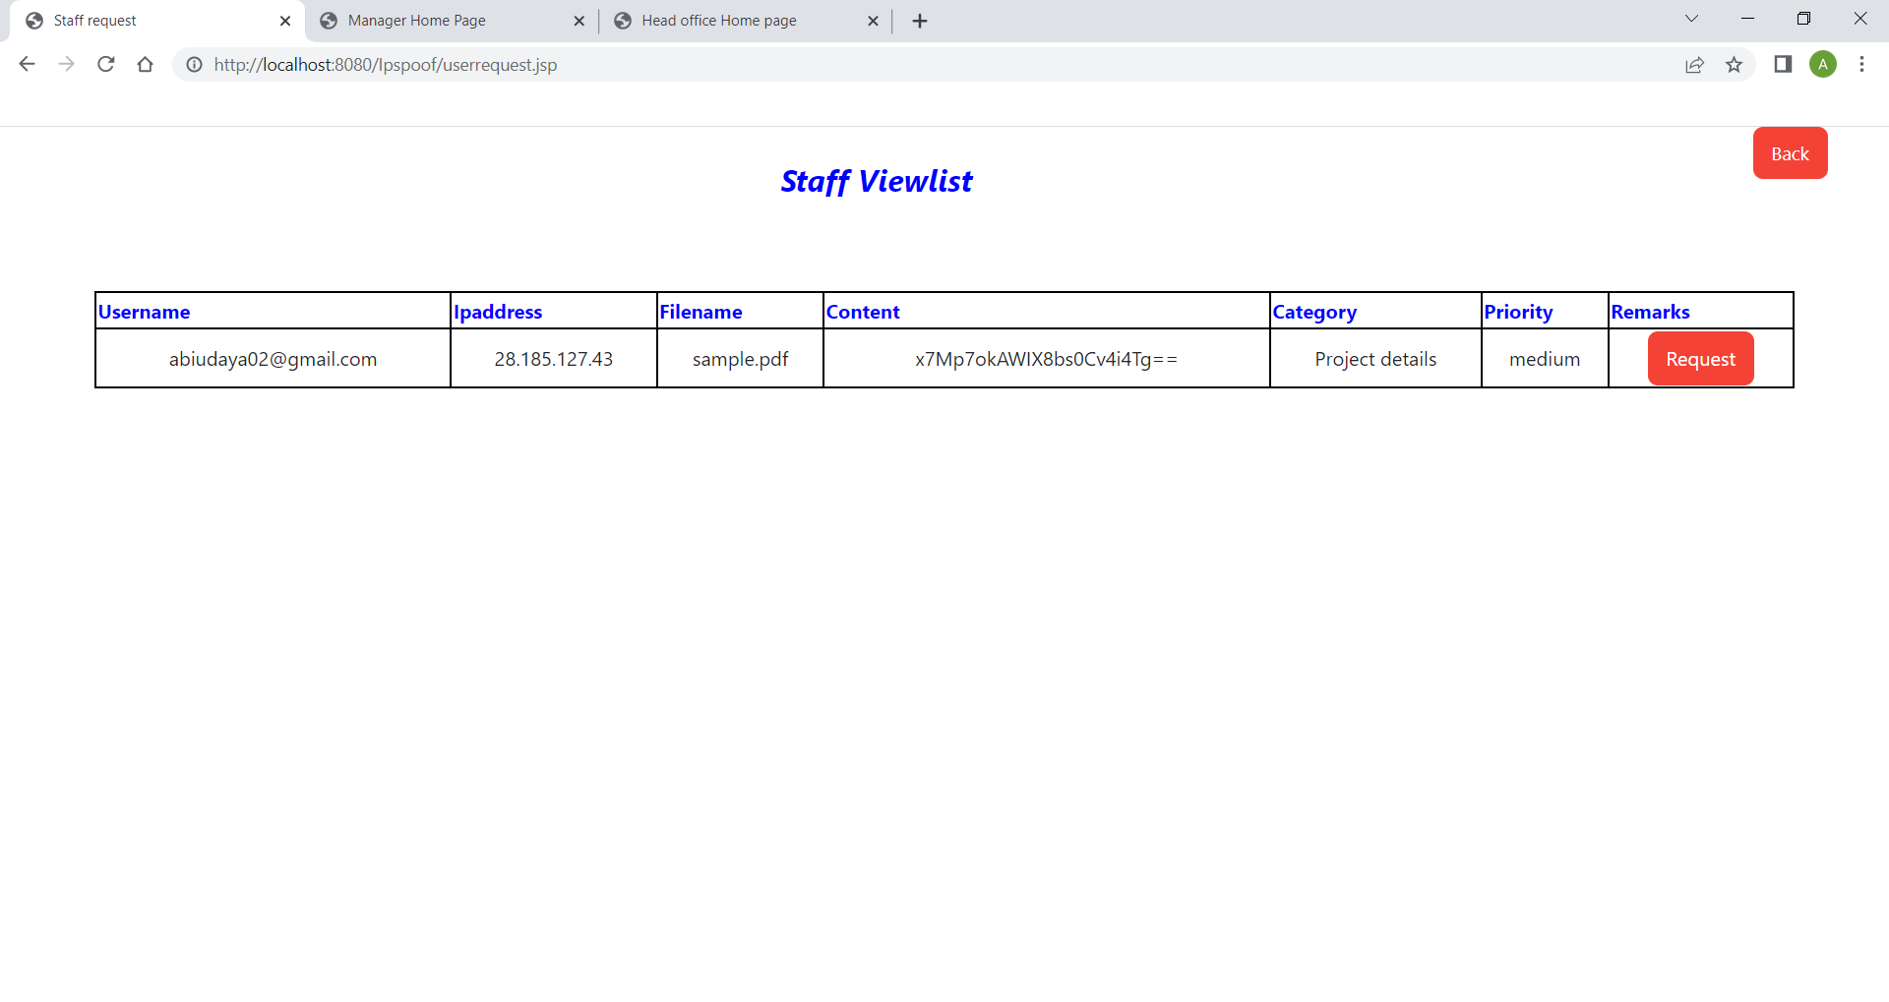

**Scr 2.5. Request Page**

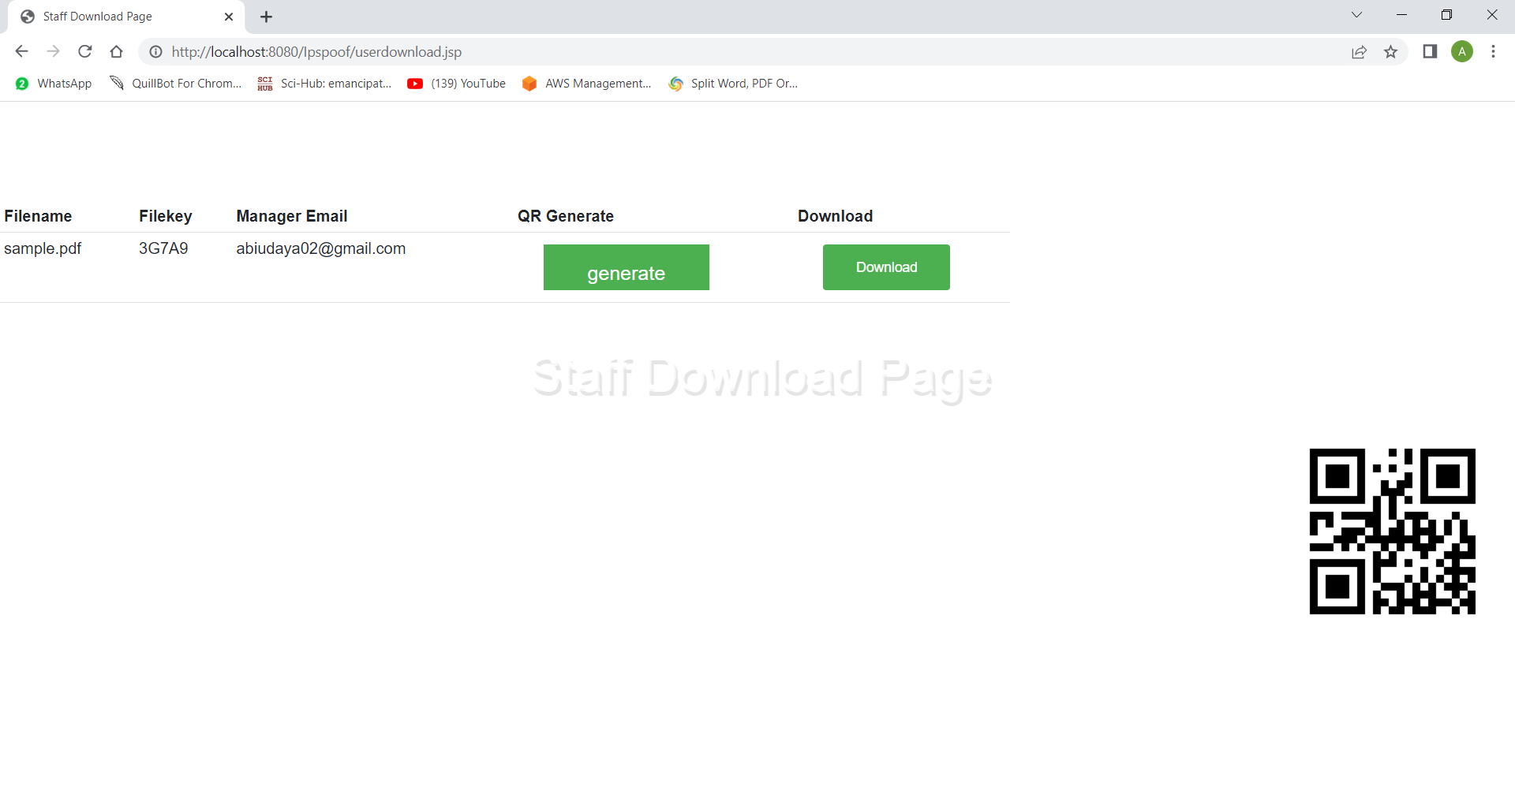

**Scr 2.6. Download Page**

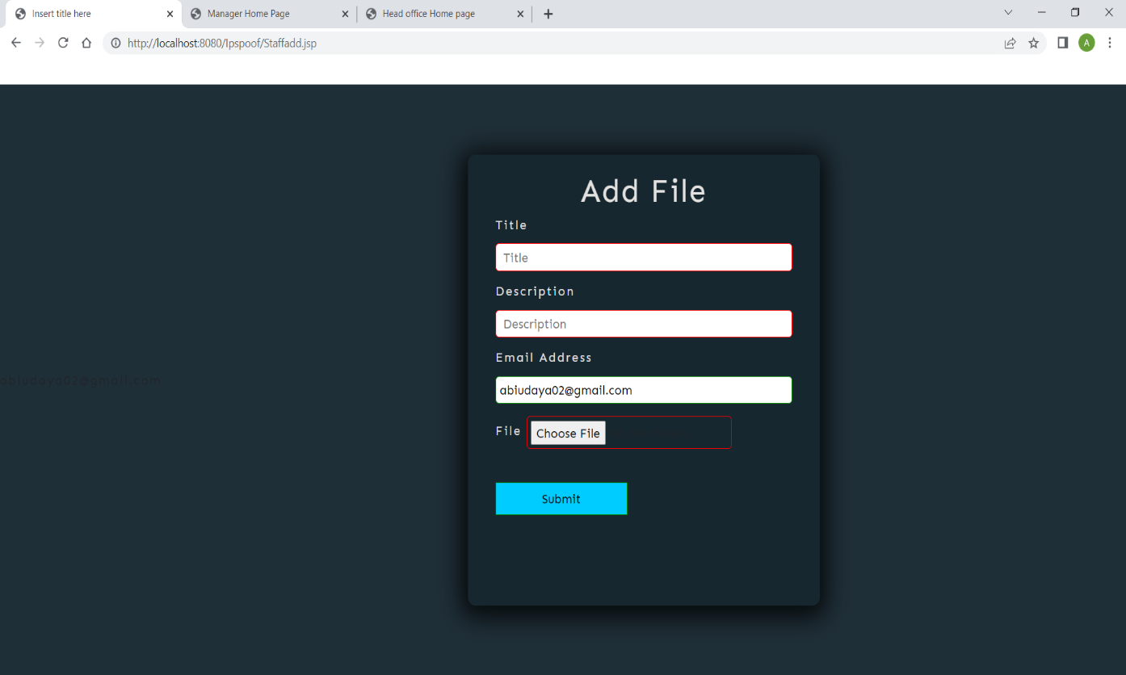

**Scr 2.7. Staff Add File Page**

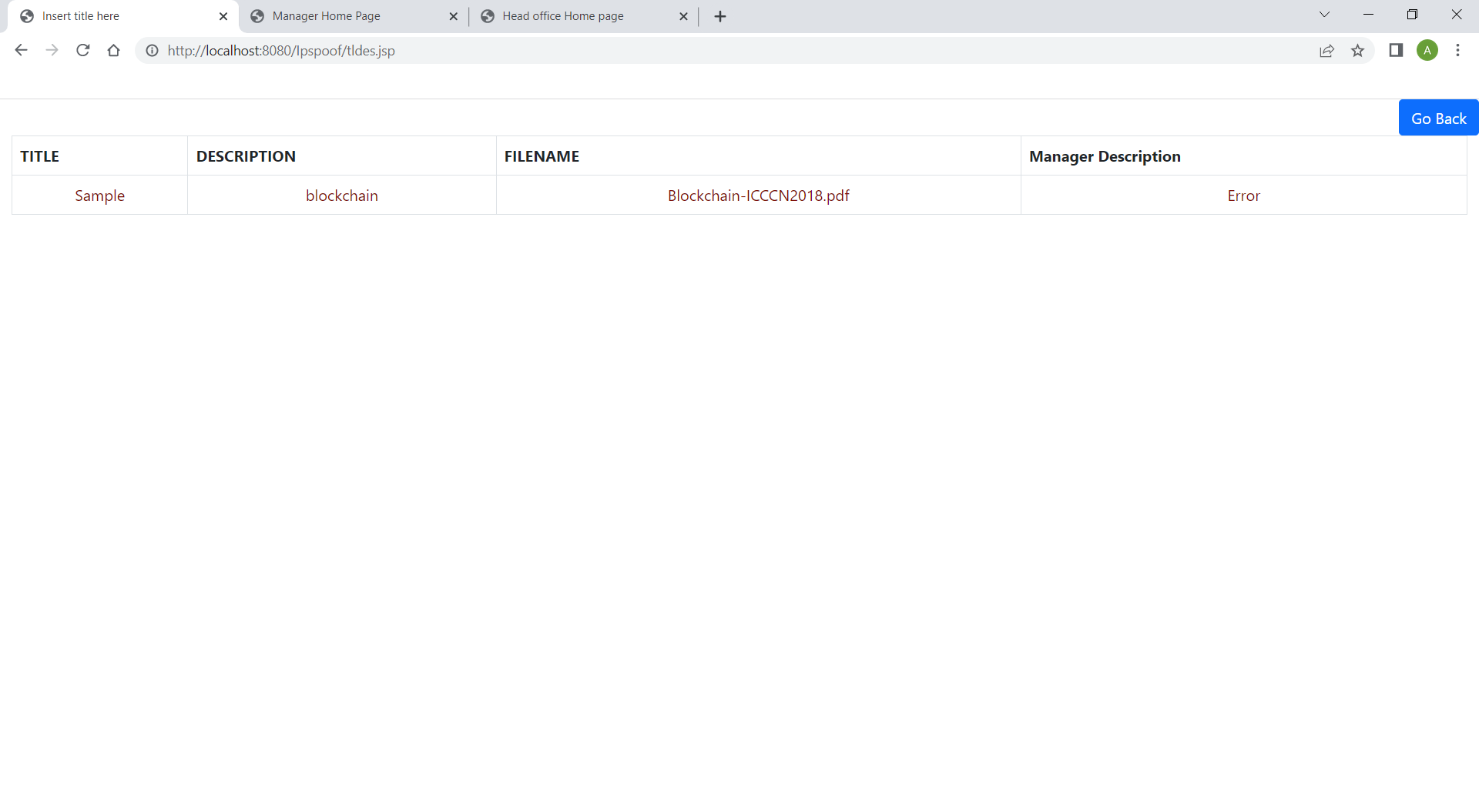

**Scr 2.8. Manager Description Page**

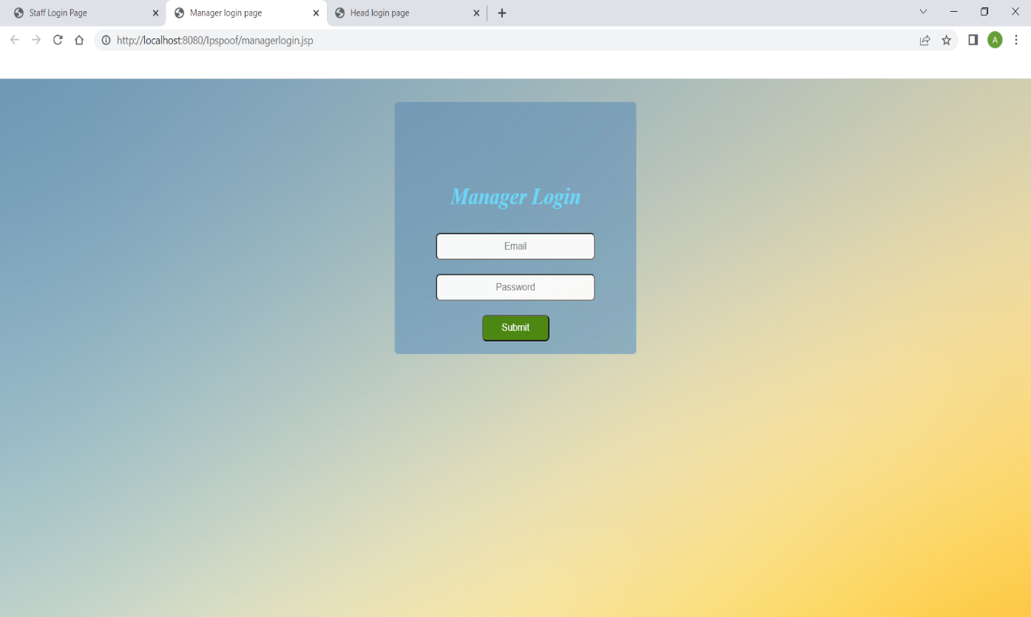

**Scr 2.9. Manager Login Page**

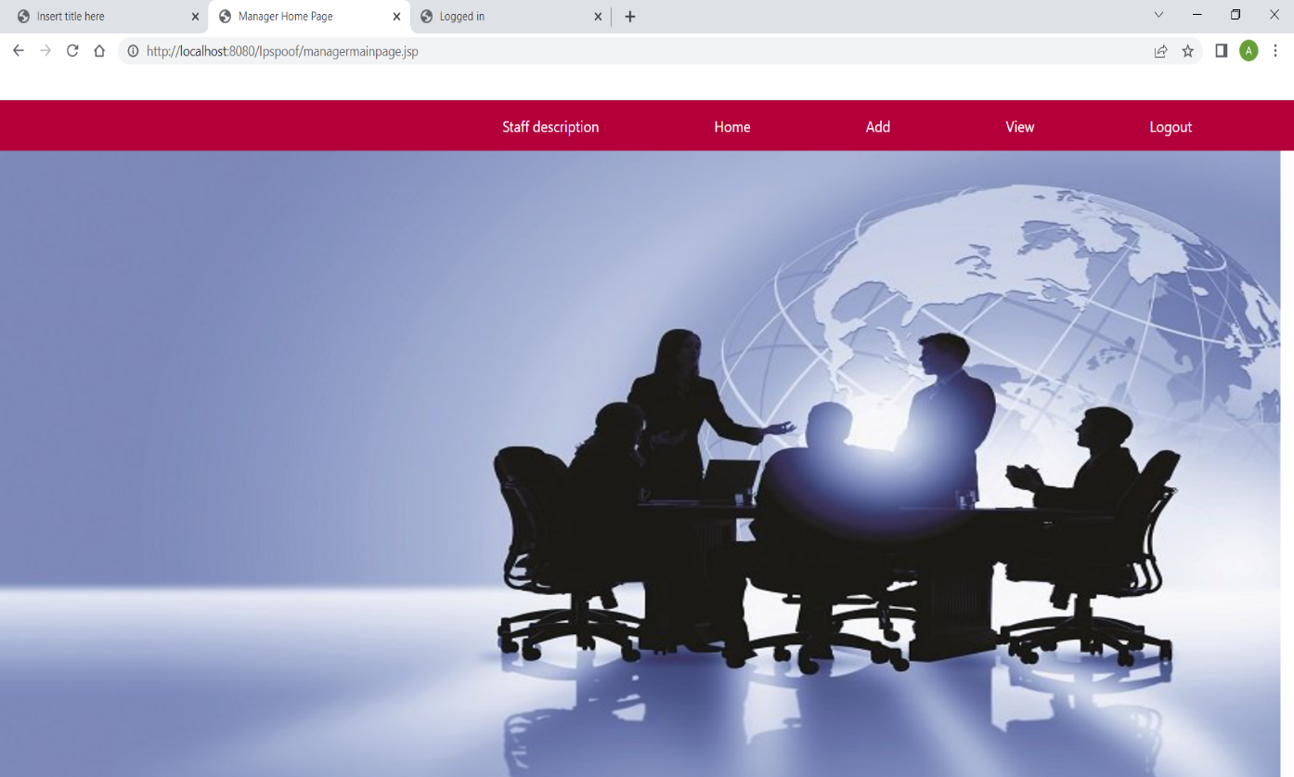

**Scr 2.10. Manager Homepage**

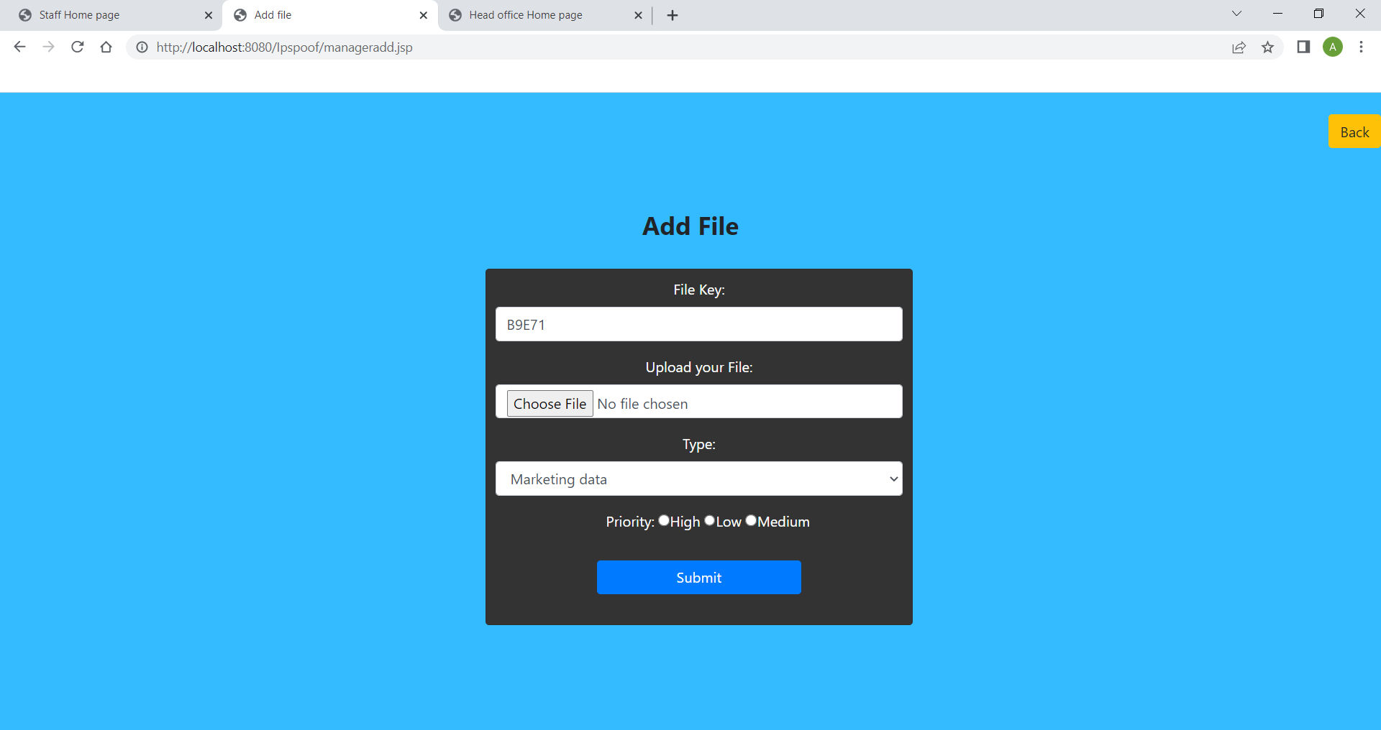

**Scr 2.11. Manager Add File Page**

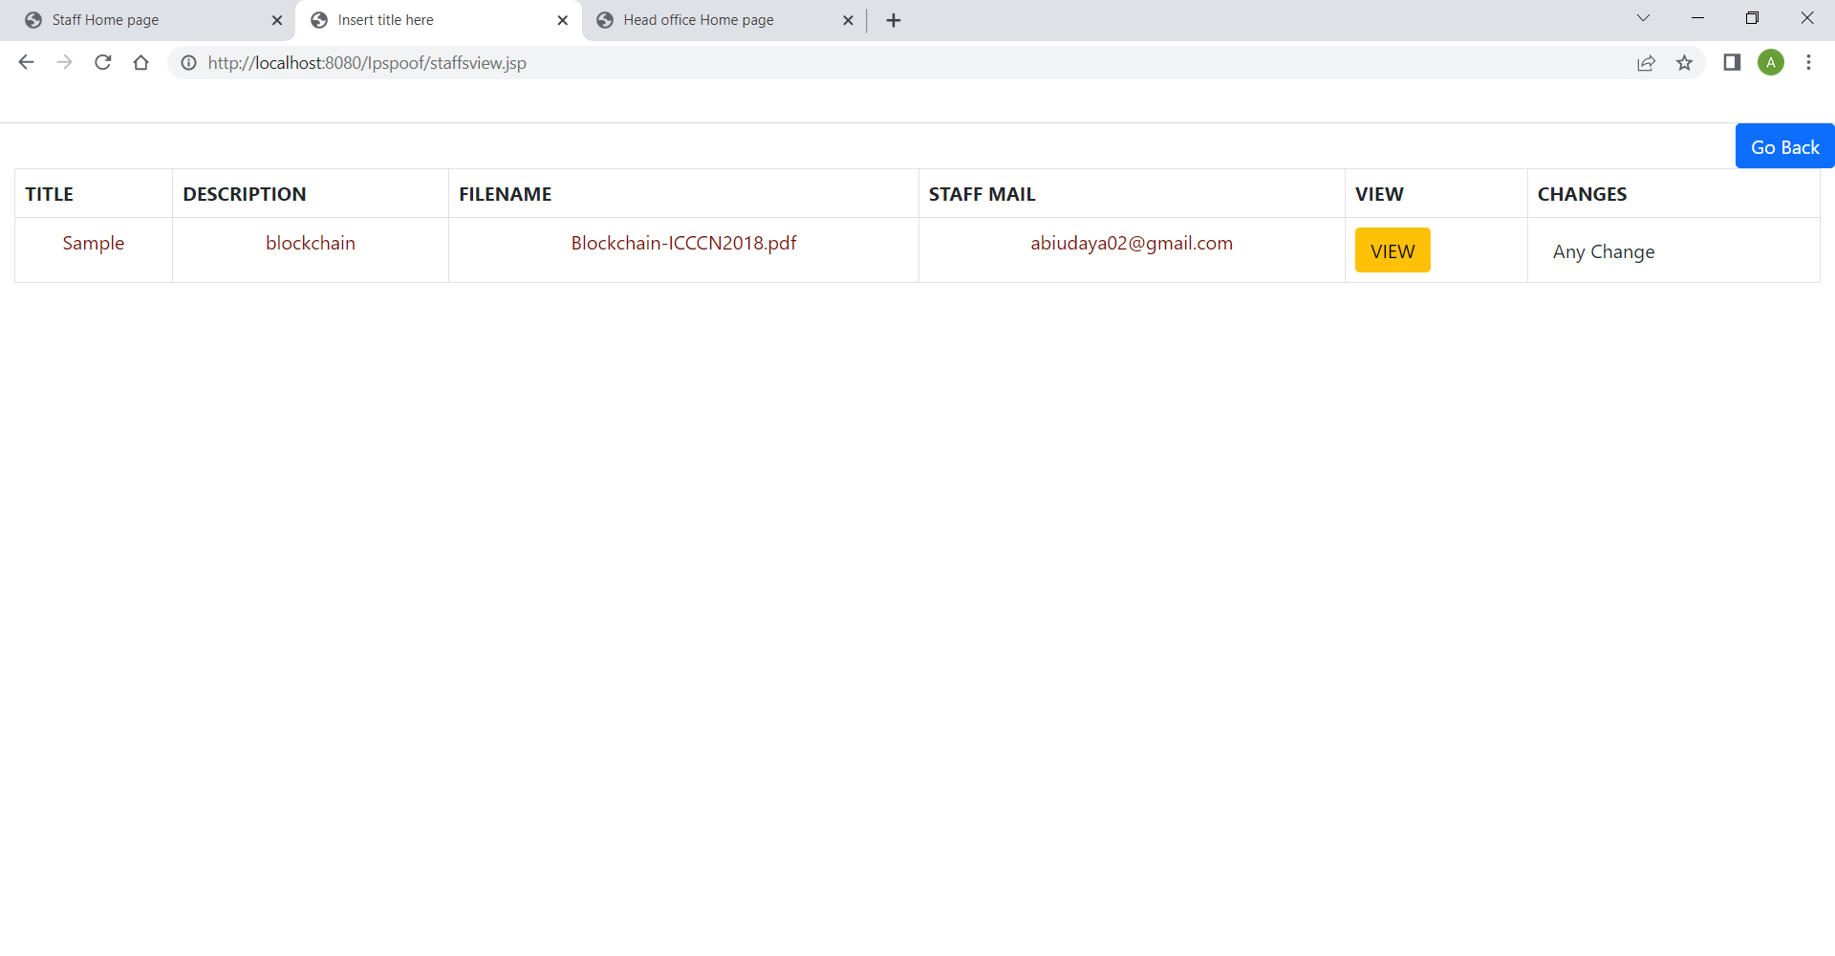

**Scr 2.12. Staff Description Page**

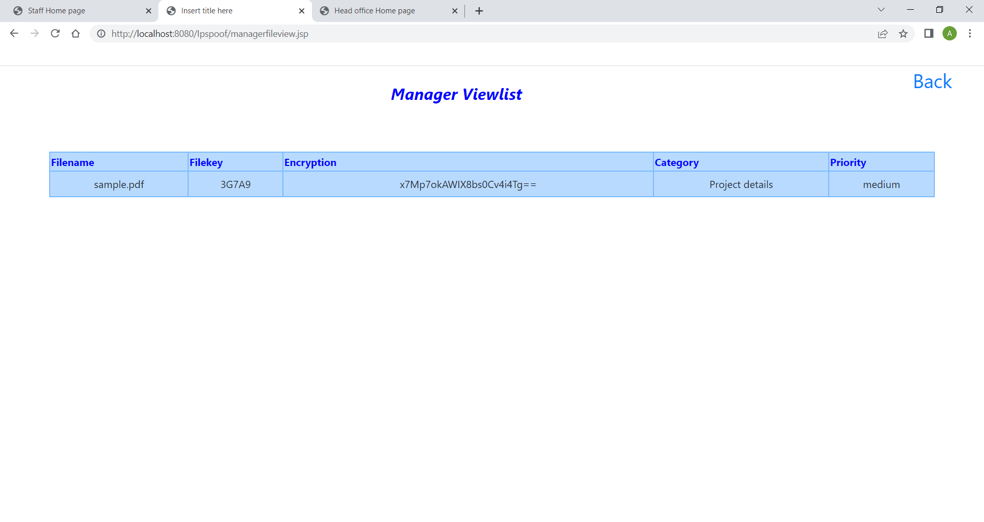

**Scr 2.13. View Page**

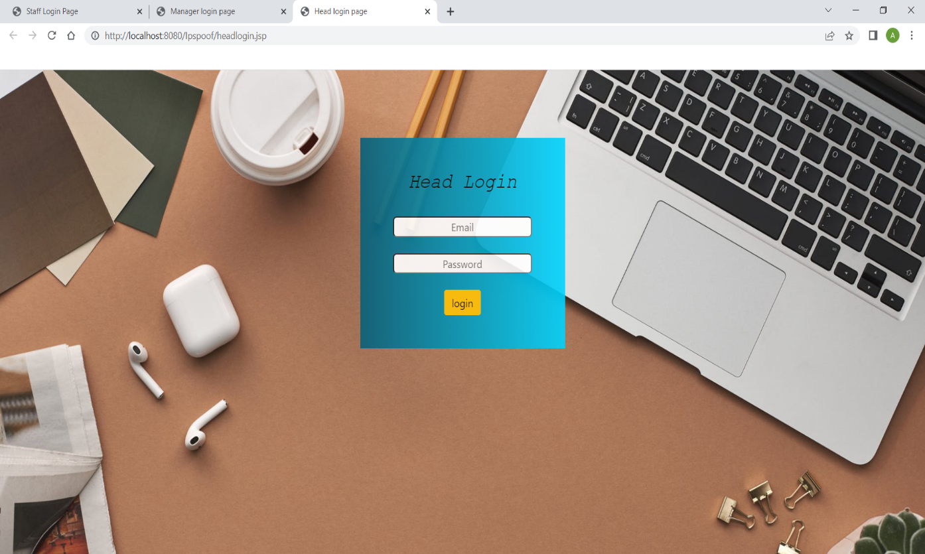

**Scr 2.14. Head Login Page**

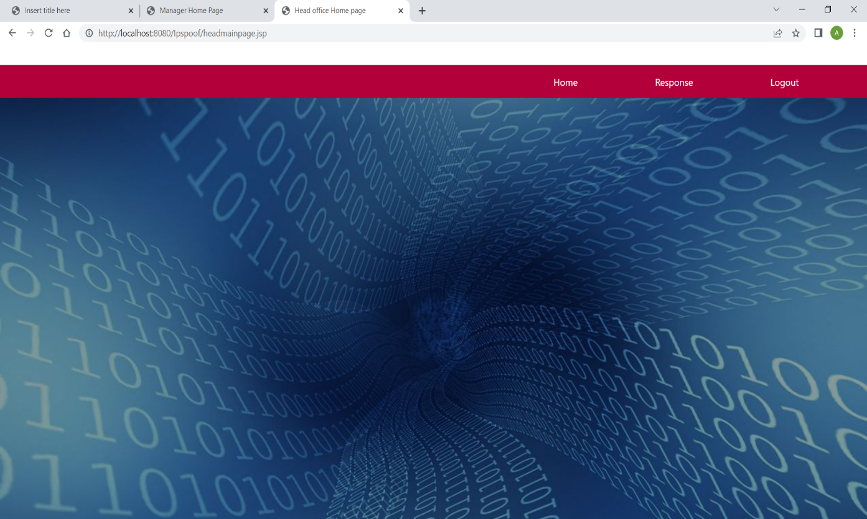

**Scr 2.15. Head Homepage**

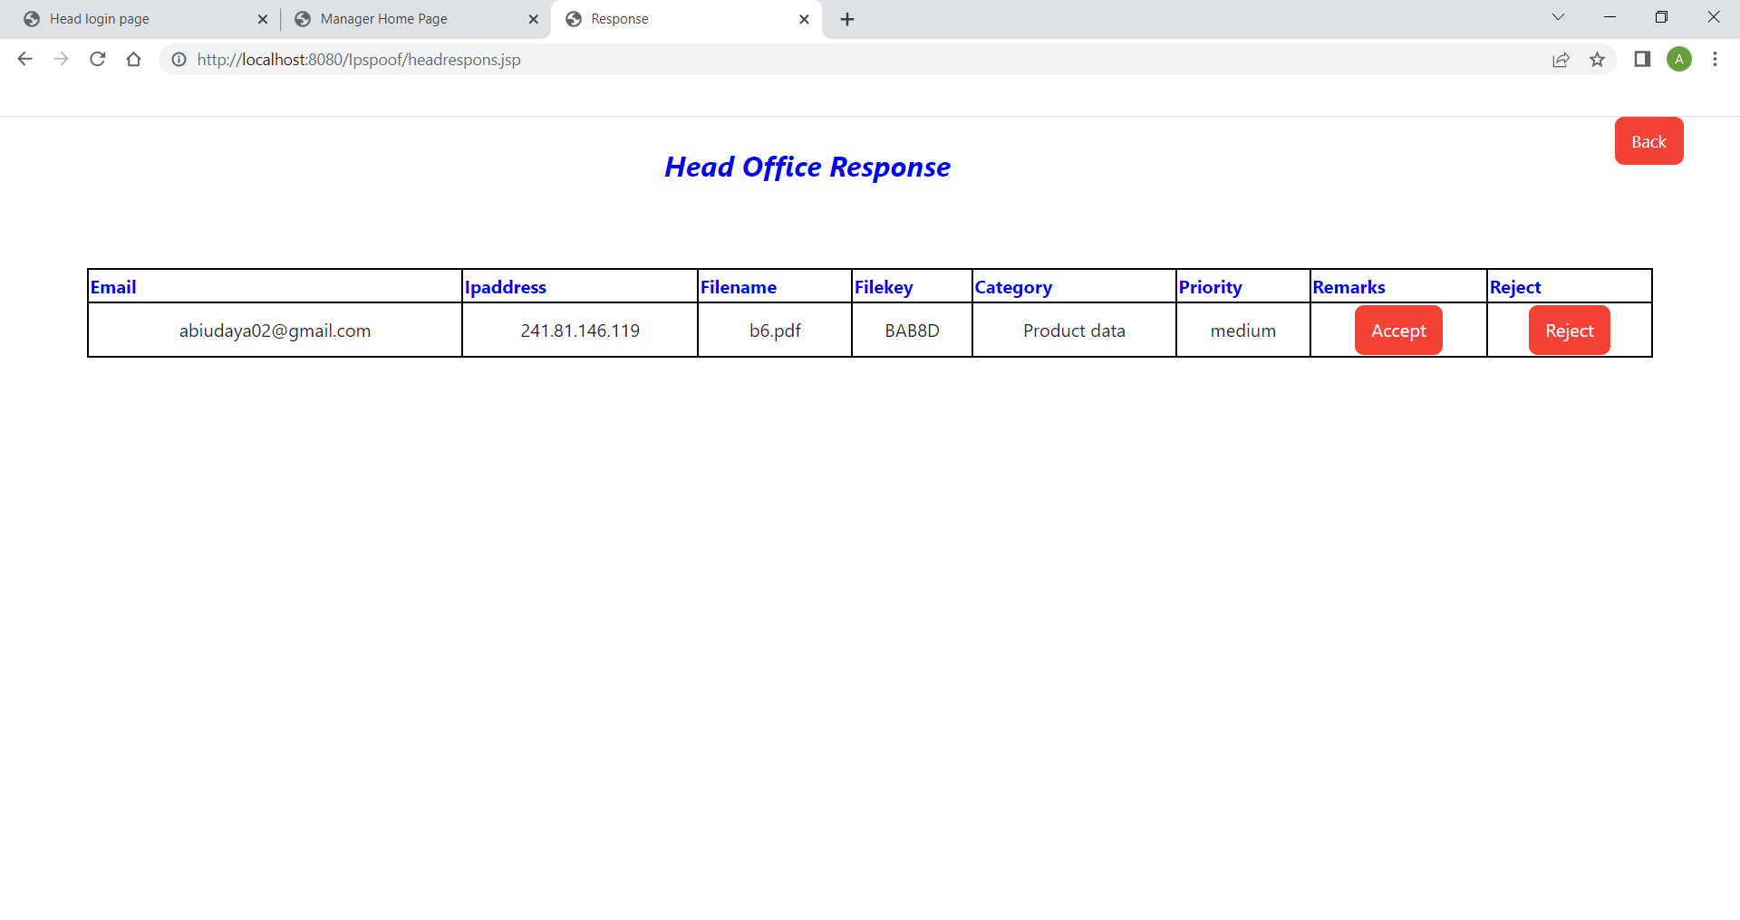

**Scr 2.16. Response Page**

**REFERENCES**

[1] Adam Bowers, Cong Liao, Douglas Steiert , Dan Lin , Anna Squicciarini, and Ali Hurson, “Detecting Suspicious File Migration or Replication in the Cloud”, 2021

[2] Anusree K, Jagan Sathiaseelan Vadekkat, Abhinu R Dev, Abhinav, “Decentralized File Transfer System Blockchain-based File Transfer”, 2022

[3] Devesh Solanki , Dev Mehta , Kaushal Modani, Sashank R M Dr Rashmi S, “An Android File Sharing System Using BlockChain & IPFS”, 2021

[4] Jin Sun, Xiaomin Yao , Shangping Wang , and Ying Wu, “Blockchain-Based Secure Storage and Access Scheme For Electronic Medical Records in IPFS”, 2020

[5] Anjaly Renny , Anjana Santhosh , Neeraja S, Teena Noyal, “File Storing and Sharing using Blockchain”, 2020

[6] Shujie Cui, Muhammad Rizwan Asghar, Giovanni Russello, ” Towards Blockchain - based Scalable and Trustworthy File Sharing”, 2018

[7] Xiaochen Zheng, Raghava Rao Mukkamala, Ravi Vatrapu, Joaqun Ordieres-Mere, “Blockchain-based Personal Health Data Sharing System Using Cloud Storage”, 2018

[8] Mathis Steichen, Beltran Fiz, Robert Norvill, Wazen Shbair and Radu, “Blockchain-Based, Decentralized Access Control for IPFS”, 2018

[9] Hoang Giang Do, Wee Keong Ng, “Blockchain-based System for Secure Data Storage with Private Keyword Search”, 2017

[10] Marlene Goncalves, Graciela Perera and Stephen Rodabaugh, “Detecting illegal file sharing in Peer-to-Peer networks using fuzzy queries”, 2010